**DEPARTMENT OF COMPUTER SCIENCE & ENGINEERING**

**Amritsar College of Engineering & Technology, Amritsar**

**(Autonomous college under UGC Act – 1956[2(f) and 12(B)] )**

**Project Report**

**On**

**“ANALYSIS OF GROCERY STORE ”**

Submitted in the Partial fulfillment of the requirement for the Award of Degree of

**Bachelor of Technology**

in

**COMPUTER SCIENCE & ENGINEERING**

Batch

(2017-2021)



**Subject-Big Data Analytics**

**(ACCS-16503)**

|  |  |
| --- | --- |
| **Submitted to**  **Er. NAVNEET BAWA** | **Submitted by**  MANISH SHARMA (1701294)  MD ARMAN(1701299) |

**INDEX PAGE**

|  |  |  |
| --- | --- | --- |
| **Sr. No.** | **Content** | **Page No.** |
| 1. | Introduction about the subject | 3 |
| 2. | Introduction of the project |  |
| 3. |  |  |
| 4. |  |  |
| 5. |  |  |
| 6. |  |  |

**An introduction to Big Data Analytics**

Big data analytics can be defined as a process of examining large and varied data sets. We use advanced analytics techniques against the large data to uncover the hidden patterns, unknown correlations, market trends, customer preferences, and other useful information. This helps the organizations to make informed decisions.

*B*[*ig data*](https://en.wikipedia.org/wiki/Big_data)analytics examines large amounts of data to uncover hidden patterns, correlations and other insights. With today’s technology, it’s possible to analyze your data and get answers from it immediately. Big Data Analytics helps you to understand your organization better. With the use of Big data analytics, one can make informed decisions without blindly relying on guesses.

**History and Evolution of Big Data Analytics**

The concept of big data has been around for years; most organizations now understand that if they capture all the data that streams into their businesses, they can apply analytics and get significant value from it. But even in the 1950s, decades before anyone uttered the term “big data,” businesses were using basic analytics essentially numbers in a spreadsheet that were manually examined to uncover insights and trends.

**Values of Big Data Analytics**

Big data analytics helps organizations harness their data and use it to identify new opportunities. That, in turn, leads to smarter business moves, more efficient operations, higher profits, and happier customers. Here are the most important values of Big Data.

Uses of Big Data analytics across different industries

Banking

Large amounts of information will be streaming into banks, managing all this data and getting proper insights would be possible only with big data analytics. This is important to understand customers and boost their satisfaction, and also to minimize risk and fraud.

Government

When government agencies are able to harness and apply analytics to their big data, they gain significant ground when it comes to managing utilities, running agencies, dealing with traffic congestion or preventing crime.

Health Care

Patient records, Treatment plans, Prescription information. When it comes to health care, everything needs to be done quickly, accurately. And, in some cases, with enough transparency to satisfy stringent industry regulations. When big data is managed effectively, health care providers can uncover hidden insights that improve patient care.

Education

Educators armed with data-driven insight can make a significant impact on school systems, students, and curriculums. By analyzing big data, they can identify at-risk students, make sure students are making adequate progress, and can implement a better system for evaluation and support of teachers and principals.

Manufacturing

Armed with insight that big data can provide, manufacturers can boost quality and output while minimizing waste – processes that are key in today’s highly competitive market. More and more manufacturers are working in an analytics-based culture, which means they can solve problems faster and make more agile business decisions.

Retail

Customer relationship building is critical to the retail industry. And the best way to manage that is to manage big data. Retailers need to know the best way to market to customers. The most effective way to handle transactions and the most strategic way to bring back lapsed business. Big data remains at the heart of all those things.

Final Thoughts

Apart from the wide range of benefits Big Data Analytics offers, there are some pitfalls like lack of internal analytic skills and hiring a skilled data scientist and data engineers to fill this gap will cost you more money.

Sometimes Data management issues may arise depending upon the amount and variety of data involved. In addition, integrating Hadoop, Spark and other big data tools into a cohesive architecture that meets an organization’s big data analytics needs is a challenging proposition for many IT and analytics teams, which have to identify the right mix of technologies and then put the pieces together.

**Hadoop Ecosystem**

**Introduction**

*Hadoop Ecosystem*is a platform or a suite which provides various services to solve the big data problems. It includes Apache projects and various commercial tools and solutions. There are *four major elements of Hadoop* i.e. **HDFS, MapReduce, YARN, and Hadoop Common**. Most of the tools or solutions are used to supplement or support these major elements. All these tools work collectively to provide services such as absorption, analysis, storage and maintenance of data etc.

Following are the components that collectively form a Hadoop ecosystem:

* **HDFS:**Hadoop Distributed File System
* **YARN:** Yet Another Resource Negotiator
* **MapReduce:** Programming based Data Processing
* **Spark:** In-Memory data processing
* **PIG, HIVE:** Query based processing of data services
* **HBase:**NoSQL Database
* **Mahout, Spark MLL ib:** [Machine Learning](https://www.geeksforgeeks.org/machine-learning/)algorithm libraries
* **Solar, Lucene:** Searching and Indexing
* **Zookeeper:** Managing cluster
* **Oozie:** Job Scheduling

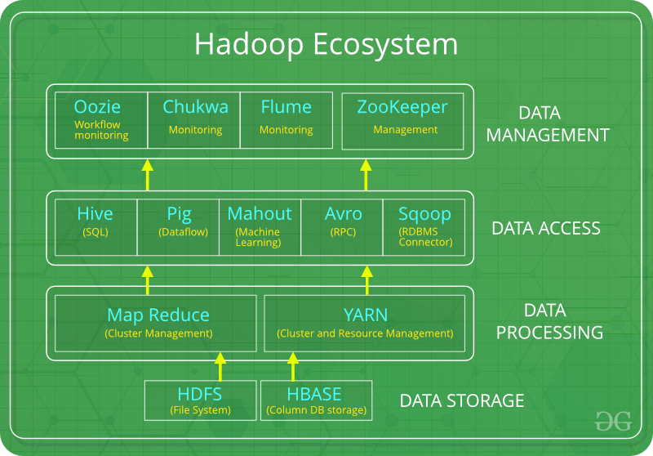

**HDFS:**

* HDFS is the primary or major component of Hadoop ecosystem and is responsible for storing large data sets of structured or unstructured data across various nodes and thereby maintaining the metadata in the form of log files.
* HDFS consists of two core components i.e.
  1. Name node
  2. Data Node
* Name Node is the prime node which contains metadata (data about data) requiring comparatively fewer resources than the data nodes that stores the actual data. These data nodes are commodity hardware in the distributed environment. Undoubtedly, making Hadoop cost effective.
* HDFS maintains all the coordination between the clusters and hardware, thus working at the heart of the system.

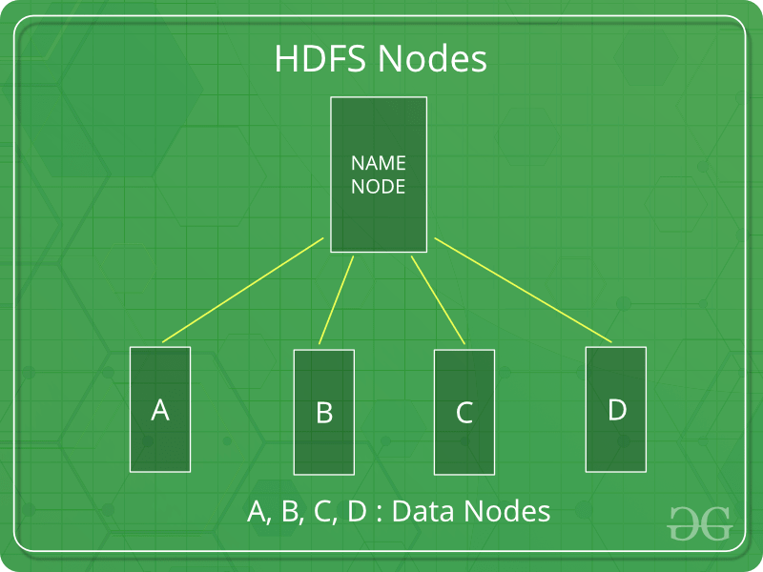

**YARN:**

* Yet Another Resource Negotiator, as the name implies, YARN is the one who helps to manage the resources across the clusters. In short, it performs scheduling and resource allocation for the Hadoop System.
* Consists of three major components i.e.
  1. Resource Manager
  2. Nodes Manager
  3. Application Manager
* Resource manager has the privilege of allocating resources for the applications in a system whereas Node managers work on the allocation of resources such as CPU, memory, bandwidth per machine and later on acknowledges the resource manager. Application manager works as an interface between the resource manager and node manager and performs negotiations as per the requirement of the two.

**Map Reduce:**

* By making the use of distributed and parallel algorithms, MapReduce makes it possible to carry over the processing’s logic and helps to write applications which transform big data sets into a manageable one.
* MapReduce makes the use of two functions i.e. Map () and Reduce () whose task is:
  1. *Map ()* performs sorting and filtering of data and thereby organizing them in the form of group. Map generates a key-value pair based result which is later on processed by the Reduce () method.
  2. *Reduce ()*, as the name suggests does the summarization by aggregating the mapped data. In simple, Reduce () takes the output generated by Map () as input and combines those tuples into smaller set of tuples.

**PIG**

* Pig was basically developed by Yahoo which works on a pig Latin language, which is Query based language similar to SQL.
* It is a platform for structuring the data flow, processing and analyzing huge data sets.
* Pig does the work of executing commands and in the background, all the activities of MapReduce are taken care of. After the processing, pig stores the result in HDFS.
* Pig Latin language is specially designed for this framework which runs on Pig Runtime. Just the way Java runs on the [JVM](https://www.geeksforgeeks.org/jvm-works-jvm-architecture/).
* Pig helps to achieve ease of programming and optimization and hence is a major segment of the Hadoop Ecosystem.

**HIVE:**

* With the help of SQL methodology and interface, HIVE performs reading and writing of large data sets. However, its query language is called as HQL (Hive Query Language).
* It is highly scalable as it allows real-time processing and batch processing both. Also, all the SQL datatypes are supported by Hive thus, making the query processing easier.
* Similar to the Query Processing frameworks, HIVE too comes with two components: *JDBC Drivers* and *HIVE Command Line*.
* JDBC, along with ODBC drivers work on establishing the data storage permissions and connection whereas HIVE Command line helps in the processing of queries.

**Mahout:**

* Mahout, allows Machine Learnability to a system or application. [Machine Learning](https://contribute.geeksforgeeks.org/geek/ml-what-is-machine-learning-2/), as the name suggests helps the system to develop itself based on some patterns, user/environmental interaction or om the basis of algorithms.
* It provides various libraries or functionalities such as collaborative filtering, clustering, and classification which are nothing but concepts of Machine learning. It allows invoking algorithms as per our need with the help of its own libraries.

**Apache Spark:**

* It’s a platform that handles all the process consumptive tasks like batch processing, interactive or iterative real-time processing, graph conversions, and visualization, etc.
* It consumes in memory resources hence, thus being faster than the prior in terms of optimization.
* Spark is best suited for real-time data whereas Hadoop is best suited for structured data or batch processing, hence both are used in most of the companies interchangeably.

**Apache HBase:**

* It’s a NoSQL database which supports all kinds of data and thus capable of handling anything of Hadoop Database. It provides capabilities of Google’s Big Table, thus able to work on Big Data sets effectively.
* At times where we need to search or retrieve the occurrences of something small in a huge database, the request must be processed within a short quick span of time. At such times, HBase comes handy as it gives us a tolerant way of storing limited data.

**Other Components:** Apart from all of these, there are some other components too that carry out a huge task in order to make Hadoop capable of processing large datasets. They are as follows:

* **Solr , Lucene:**These are the two services that perform the task of searching and indexing with the help of some java libraries, especially Lucene is based on Java which allows spell check mechanism, as well. However, Lucene is driven by Solr.
* **Zookeeper:**There was a huge issue of management of coordination and synchronization among the resources or the components of Hadoop which resulted in inconsistency, often. Zookeeper overcame all the problems by performing synchronization, inter-component based communication, grouping, and maintenance.
* **Oozie:**Oozie simply performs the task of a scheduler, thus scheduling jobs and binding them together as a single unit. There is two kinds of jobs i.e Oozie workflow and Oozie coordinator jobs. Oozie workflow is the jobs that need to be executed in a sequentially ordered manner whereas Oozie Coordinator jobs are those that are triggered when some data or external stimulus is given to it.

## **HDFS Architecture:**

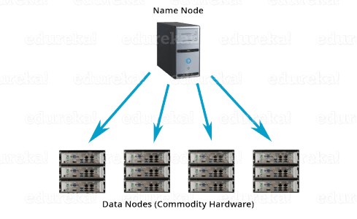

**Apache HDFS** or **Hadoop Distributed File System** is a block-structured file system where each file is divided into blocks of a pre-determined size. These blocks are stored across a cluster of one or several machines. Apache Hadoop HDFS Architecture follows a Master/Slave Architecture, where a cluster comprises of a single Name Node (Master node) and all the other nodes are Data Nodes (Slave nodes). HDFS can be deployed on a broad spectrum of machines that support Java. Though one can run several Data Nodes on a single machine, but in the practical world, these Data Nodes are spread across various machines.

## **Name Node:**

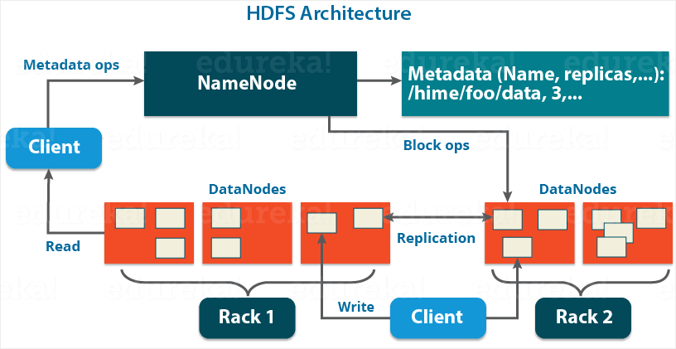

Name Node is the master node in the Apache Hadoop HDFS Architecture that maintains and manages the blocks present on the Data Nodes (slave nodes). Name Node is a very highly available server that manages the File System Namespace and controls access to files by clients. I will be discussing this High Availability feature of Apache Hadoop HDFS in my next blog. The HDFS architecture is built in such a way that the user data never resides on the Name Node. The data resides on Data Nodes only.

### Functions of Name Node:

* It is the master daemon that maintains and manages the Data Nodes (slave nodes)
* It records the metadata of all the files stored in the cluster, e.g. The location of blocks stored, the size of the files, permissions, hierarchy, etc. There are two files associated with the metadata:
  + - * **Fs Image:** It contains the complete state of the file system namespace since the start of the Name Node.
      * **Edit Logs:** It contains all the recent modifications made to the file system with respect to the most recent Fs Image.
* It records each change that takes place to the file system metadata. For example, if a file is deleted in HDFS, the Name Node will immediately record this in the Edit Log.
* It regularly receives a Heartbeat and a block report from all the Data Nodes in the cluster to ensure that the Data Nodes are live.
* It keeps a record of all the blocks in HDFS and in which nodes these blocks are located.
* The Name Node is also responsible to take care of the **replication factor**of all the blocks which we will discuss in detail later in this HDFS tutorial blog.
* In **case of the Data Node failure**, the Name Node chooses new Data Nodes for new replicas, balance disk usage and manages the communication traffic to the Data Nodes.

## **Data Node:**

Data Nodes are the slave nodes in HDFS. Unlike Name Node, Data Node is a commodity hardware, that is, a non-expensive system which is not of high quality or high-availability. The Data Node is a block server that stores the data in the local file ext3 or ext4.

### Functions of Data Node**:**

* These are slave daemons or process which runs on each slave machine.
* The actual data is stored on Data Nodes.
* The Data Nodes perform the low-level read and write requests from the file system’s clients.
* They send heartbeats to the Name Node periodically to report the overall health of HDFS, by default, this frequency is set to 3 seconds.

Till now, you must have realized that the Name Node is pretty much important to us. If it fails, we are doomed.  But don’t worry, we will be talking about how Hadoop solved this single point of failure problem in the next Apache Hadoop HDFS Architecture blog. So, just relax for now and let’s take one step at a time.

## **Secondary Name Node:**

Apart from these two daemons, there is a third daemon or a process called Secondary Name Node. The Secondary Name Node works concurrently with the primary Name Node as a **helper daemon.**And don’t be confused about the Secondary Name Node being a**backup Name Node because it is not.**

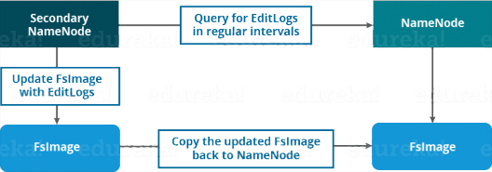

### Functions of Secondary Name Node:

* The Secondary Name Node is one which constantly reads all the file systems and metadata from the RAM of the Name Node and writes it into the hard disk or the file system.
* It is responsible for combining the Edit Logs with Fs Image from the Name Node.
* It downloads the Edit Logs from the Name Node at regular intervals and applies to Fs Image. The new Fs Image is copied back to the Name Node, which is used whenever the Name Node is started the next time.

Hence, Secondary Name Node performs regular checkpoints in HDFS. Therefore, it is also called Check point Node.

## **Blocks:**

Blocks are the nothing but the smallest continuous location on your hard drive where data is stored. In general, in any of the File System, you store the data as a collection of blocks. Similarly, HDFS stores each file as blocks which are scattered throughout the Apache Hadoop cluster. The default size of each block is 128 MB in Apache Hadoop 2.x (64 MB in Apache Hadoop 1.x) which you can configure as per your requirement.

## **Replication Management:**

HDFS provides a reliable way to store huge data in a distributed environment as data blocks. The blocks are also replicated to provide fault tolerance. The default replication factor is 3 which is again configurable. So, as you can see in the figure below where each block is replicated three times and stored on different Data Nodes (considering the default replication factor):

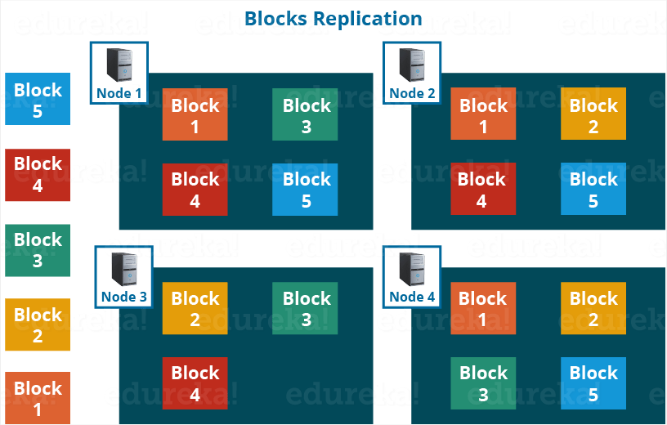

Therefore, if you are storing a file of 128 MB in HDFS using the default configuration, you will end up occupying a space of 384 MB (3*128 MB) as the blocks will be replicated three

**HDFS:**

**Apache HDFS** or **Hadoop Distributed File System** is a block-structured file system where each file is divided into blocks of a pre-determined size. These blocks are stored across a cluster of one or several machines. Apache Hadoop HDFS Architecture follows a Master/Slave Architecture, where a cluster comprises of a single NameNode (Master node) and all the other nodes are DataNodes (Slave nodes). HDFS can be deployed on a broad spectrum of machines that support Java. Though one can run several DataNodes on a single machine, but in the practical world, these DataNodes are spread across various machines..

**Features of HDFS**

* It is suitable for the distributed storage and processing.
* Hadoop provides a command interface to interact with HDFS.
* The built-in servers of namenode and datanode help users to easily check the status of cluster.
* Streaming access to file system data.
* HDFS provides file permissions and authentication.

**HDFS Architecture:**



HDFS follows the master-slave architecture and it has the following elements.

**NameNode:**

NameNode is the master node in the Apache Hadoop HDFS Architecture that maintains and manages the blocks present on the DataNodes (slave nodes). NameNode is a very highly available server that manages the File System Namespace and controls access to files by clients. I will be discussing this High Availability feature of Apache Hadoop HDFS in my next blog. The HDFS architecture is built in such a way that the user data never resides on the NameNode. The data resides on DataNodes only.

**Functions of NameNode:**

* It is the master daemon that maintains and manages the DataNodes (slave nodes)
* It records the metadata of all the files stored in the cluster, e.g. The location of blocks stored, the size of the files, permissions, hierarchy, etc. There are two files associated with the metadata:
  + FsImage: It contains the complete state of the file system namespace since the start of the NameNode.
  + EditLogs: It contains all the recent modifications made to the file system with respect to the most recent FsImage.
* It records each change that takes place to the file system metadata. For example, if a file is deleted in HDFS, the NameNode will immediately record this in the EditLog.
* It regularly receives a Heartbeat and a block report from all the DataNodes in the cluster to ensure that the DataNodes are live.
* It keeps a record of all the blocks in HDFS and in which nodes these blocks are located.
* The NameNode is also responsible to take care of the **replication factor**of all the blocks which we will discuss in detail later in this HDFS tutorial blog.
* In **case of the DataNode failure**, the NameNode chooses new DataNodes for new replicas, balance disk usage and manages the communication traffic to the DataNodes.

**DataNode:**

DataNodes are the slave nodes in HDFS. Unlike NameNode, DataNode is a commodity hardware, that is, a non-expensive system which is not of high quality or high-availability. The DataNode is a block server that stores the data in the local file ext3 or ext4.

**Functions of DataNode:**

* These are slave daemons or process which runs on each slave machine.
* The actual data is stored on DataNodes.
* The DataNodes perform the low-level read and write requests from the file system’s clients.
* They send heartbeats to the NameNode periodically to report the overall health of HDFS, by default, this frequency is set to 3 seconds.

Till now, you must have realized that the NameNode is pretty much important to us. If it fails, we are doomed.  But don’t worry, we will be talking about how Hadoop solved this single point of failure problem in the next Apache Hadoop HDFS Architecture blog. So, just relax for now and let’s take one step at a time.

## **Secondary NameNode:**

Apart from these two daemons, there is a third daemon or a process called Secondary NameNode. The Secondary NameNode works concurrently with the primary NameNode as a **helper daemon.** And don’t be confused about the Secondary NameNode being a **backup NameNode because it is not.**

**Functions of Secondary NameNode:**

* The Secondary NameNode is one which constantly reads all the file systems and metadata from the RAM of the NameNode and writes it into the hard disk or the file system.
* It is responsible for combining the EditLogs with FsImage from the NameNode.
* It downloads the EditLogs from the NameNode at regular intervals and applies to FsImage. The new FsImage is copied back to the NameNode, which is used whenever the NameNode is started the next time.

Hence, Secondary NameNode performs regular checkpoints in HDFS. Therefore, it is also called CheckpointNode.

## **Blocks:**

Blocks are the nothing but the smallest continuous location on your hard drive where data is stored. In general, in any of the File System, you store the data as a collection of blocks. Similarly, HDFS stores each file as blocks which are scattered throughout the Apache Hadoop cluster. The default size of each block is 128 MB which you can configure as per your requirement.

It is not necessary that in HDFS, each file is stored in exact multiple of the configured block size (128 MB, 256 MB etc.). Let’s take an example where I have a file “example.txt” of size 514 MB as shown in above figure.  Suppose that we are using the default configuration of block size, which is 128 MB. Then, how many blocks will be created? 5, Right. The first four blocks will be of 128 MB. But, the last block will be of 2 MB size only.

## **Replication Management:**

HDFS provides a reliable way to store huge data in a distributed environment as data blocks. The blocks are also replicated to provide fault tolerance. The default replication factor is 3 which is again configurable. So, as you can see in the figure below where each block is replicated three times and stored on different DataNodes (considering the default replication factor):

Therefore, if you are storing a file of 128 MB in HDFS using the default configuration, you will end up occupying a space of 384 MB (3*128 MB) as the blocks will be replicated three times and each replica will be residing on a different DataNode. 

**Note:** The NameNode collects block report from DataNode periodically to maintain the replication factor. Therefore, whenever a block is over-replicated or under-replicated the NameNode deletes or add replicas as needed.

**Hadoop Shell Commands:**

**1.cat:**

Copies source paths to stdout.

Usage: hadoop fs -cat URI [URI …]

Example: hdfs dfs -cat sample

**2. chgrp:**

Change group association of files. With -R, make the change recursively through the directory structure. The user must be the owner of files, or else a super-user. Additionalinformation is in the Permissions User Guide.

Usage: hadoop fs -chgrp [-R] GROUP URI [URI …]

Example: hdfs dfs -chgrp [-R] New Group sample

**3. chmod:**

Change the permissions of files. With -R, make the change recursively through the directorystructure. The user must be the owner of the file, or else a super-user. Additional informationis in the Permissions User Guide.

Usage: hadoop fs -chmod [-R] <MODE[,MODE]... | OCTALMODE> URI

[URI …]

Example: hdfs dfs -chmod 777 /user/hadoop/dir1/sample

**4. chown:**

Change the owner of files. With -R, make the change recursively through the directory

structure. The user must be a super-user. Additional information is in the Permissions User Guide.

Usage: hadoop fs -chown [-R] [OWNER][:[GROUP]] URI [URI ]

Example: hdfs dfs -chown -R xdark/opt/hadoop/logs

**5. put:**

Copy single src, or multiple srcs from local file system to the destination filesystem. Also

reads input from stdin and writes to destination filesystem.

Usage: hadoop fs -put <localsrc> ... <dst>

Example: hdfs dfs -put /home/xdark/Desktop/sample /user/hadoop

**6. copyFromLocal:**

Similar to put command, except that the source is restricted to a local file reference.

Usage: hadoop fs -copyFromLocal <localsrc> URI

Example: hdfs dfs -copyFromLocal /home/xdark/Desktop/sample /user/hadoop

**7. copyToLocal:**

Similar to get command, except that the destination is restricted to a local file reference.

Usage: hadoop fs -copyToLocal [-ignorecrc] [-crc] URI

<localdst>

Example: hdfs dfs -copyToLocal /user/hadoop/sample /home/xdark/Desktop

**8. cp:**

Copy files from source to destination. This command allows multiple sources as well in

which case the destination must be a directory.

Usage: hadoop fs -cp URI [URI …] <dest>

Example: hadoop fs -cp /user/hadoop/dir2/purchases.txt /user/hadoop/dir1

**9. du:**

Displays aggregate length of files contained in the directory or the length of a file in case its

just a file.

Usage: hadoop fs -du URI [URI …]

Example: hdfs dfs -du /user/hadoop/dir1/sample

**10. dus:**

Displays a summary of file lengths.

Usage: hadoop fs -dus <args>

Example: hdfs dfs -dus /sample

**11. expunge:**

Empty the Trash. Refer to HDFS Design for more information on Trash feature.

Usage: hadoop fs –expunge

Example: hdfs dfs -expunge

**12. get:**

Copy files to the local file system. Files that fail the CRC check may be copied with the

-ignorecrc option. Files and CRCs may be copied using the -crc option.

Usage: hadoop fs -get [-ignorecrc] [-crc] <src> <localdst>

Example: hdfs dfs -get /user/hadoop/dir2/sample /home/dataflair/Desktop

**13. getmerge:**

Takes a source directory and a destination file as input and concatenates files in src into the

destination local file. Optionally addnl can be set to enable adding a newline character at

the end of each file.

Usage: hadoop fs -getmerge <src> <localdst> [addnl]

Example: hdfs dfs -getmerge /user/hadoop/dir1/sample.txt /user/hadoop/dir2/sample2.txt

/home/sample1.txt

**14. ls:**

For a file returns stat on the file with the following format:

filename <number of replicas> filesize modification_date

modification_time permissions userid groupid

For a directory it returns list of its direct children as in unix. A directory is listed as:

dirname <dir> modification_time modification_time permissions

userid groupid

Usage: hadoop fs -ls <args>

Example: hdfs dfs -ls /user/hadoop/dir1

**15. lsr:**

Recursive version of ls. Similar to Unix ls -R.

Usage: hadoop fs -lsr <args>

Example: hadoop fs -lsr

**16. mkdir:**

Takes path uri's as argument and creates directories. The behavior is much like unix mkdir -p

creating parent directories along the path.

Usage: hadoop fs -mkdir <paths>

Example: hdfs dfs -mkdir /user/hadoop/dir1

**17. movefromLocal:**

Displays a "not implemented" message.

Usage: dfs -moveFromLocal <src> <dst>

Example: hdfs dfs -moveFromLocal /home/xdark/Desktop/sample /user/hadoop/dir1

**18. mv:**

Moves files from source to destination. This command allows multiple sources as well in

which case the destination needs to be a directory. Moving files across filesystems is not

permitted.

Usage: hadoop fs -mv URI [URI …] <dest>

Example: hdfs dfs -mv myfile.txt /dir1

**19. rm:**

Delete files specified as args. Only deletes non empty directory and files. Refer to rmr for

recursive deletes.

Usage: hadoop fs -mv URI [URI …] <dest>

Example: hdfs dfs -rm /user/hadoop/dir2/sample

**20. rmr:**

Recursive version of delete.

Usage: hadoop fs -rmr URI [URI …]

Example: hdfs dfs -rmr /sample

**21. setrep:**

Changes the replication factor of a file. -R option is for recursively increasing the replication

factor of files within a directory.

Usage: hadoop fs -setrep [-R] <path>

Example: hdfs dfs -setrep -w 3 /user/hadoop/dir1

**22. stat:**

Returns the stat information on the path.

Usage: hadoop fs -tail [-f] URI

Example: hdfs dfs -stat /user/hadoop/dir1

**23. tail:**

Displays last kilobyte of the file to stdout. -f option can be used as in Unix.

Usage: hadoop fs -tail [-f] URI

Example: hdfs dfs -tail -f /user/hadoop/dir2/purchases.txt

**24. test:**

The [Hadoop](http://data-flair.training/blogs/difference-comparison-hadoop-2-x-vs-hadoop-3-x/) fs shell command test is used for file test operations.  
It gives 1 output if a path exists; it has zero length, or it is a directory or otherwise 0.

Options:

-e check to see if the file exists. Return 0 if true.

-z check to see if the file is zero length. Return 0 if true

-d check return 1 if the path is directory else return 0.

Usage: hadoop fs -test -[ezd] URI

Example: 1.hdfs dfs -test -e sample

2.hdfs dfs -test -z sample

3.hdfs dfs -test -d sample

**25. text:**

Takes a source file and outputs the file in text format. The allowed formats are zip and

TextRecordInputStream.

Usage: hadoop fs -text <src>

Example: hdfs dfs -text /user/hadoop/dir1/sample

**26. touchz:**

Create a file of zero length.

Usage: hadoop fs -touchz URI [URI …]

Example: hadoop fs –touchz sample

**27. version :**

This Hadoop command prints the [Hadoop](http://data-flair.training/blogs/best-hadoop-administration-books-must-read/) version

Usage: version

Example: hdfs dfs version

**28.df:**

df displays free space.This was all on Hadoop HDFS Commands.

Usage: hdfs dfs -df [-h] URI [URI ...]

Example: hdfs dfs -df -h

HDFS dfs Command Description

**Apache Pig:**

Apache Pig is an abstraction over MapReduce. It is a tool/platform which is used to analyze

larger sets of data representing them as data flows. Pig is generally used with Hadoop; we can perform all the data manipulation operations in Hadoop using Apache Pig.

To write data analysis programs, Pig provides a high-level language known as Pig Latin. Thislanguage provides various operators using which programmers can develop their own functionsfor reading, writing, and processing data.

To analyze data using Apache Pig, programmers need to write scripts using Pig Latin language.

All these scripts are internally converted to Map and Reduce tasks. Apache Pig has a componentknown as Pig Engine that accepts the Pig Latin scripts as input and converts those scripts intoMapReduce jobs.

**Apache Pig – Architecture:**

The language used to analyze data in Hadoop using Pig is known as Pig Latin. It is a highlevel

data processing language which provides a rich set of data types and operators to perform

various operations on the data.

To perform a particular task Programmers using Pig, programmers need to write a Pig script

using the Pig Latin language, and execute them using any of the execution mechanisms (Grunt

Shell, UDFs, Embedded). After execution, these scripts will go through a series of

transformations applied by the Pig Framework, to produce the desired output.

Internally, Apache Pig converts these scripts into a series of MapReduce jobs, and thus, it makes

the programmer’s job easy. The architecture of Apache Pig is shown below.



**Apache Pig Components:**

As shown in the figure, there are various components in the Apache Pig framework. Let us take a

look at the major components.

**Parser:**

Initially the Pig Scripts are handled by the Parser. It checks the syntax of the script, does type

checking, and other miscellaneous checks. The output of the parser will be a DAG (directed

acyclic graph), which represents the Pig Latin statements and logical operators.

In the DAG, the logical operators of the script are represented as the nodes and the data flows arerepresented as edges.

**Optimizer:**

The logical plan (DAG) is passed to the logical optimizer, which carries out the logical

optimizations such as projection and pushdown.

**Compiler:**

The compiler compiles the optimized logical plan into a series of MapReduce jobs.

Execution engine

Finally the MapReduce jobs are submitted to Hadoop in a sorted order. Finally, these

MapReduce jobs are executed on Hadoop producing the desired results.

**Pig Latin Data Model:**

The data model of Pig Latin is fully nested and it allows complex non-atomic datatypes such as map and tuple. Given below is the diagrammatical representation of Pig Latin’s data model.



**Atom:**

Any single value in Pig Latin, irrespective of their data, type is known as an Atom. It is stored as string and can be used as string and number. int, long, float, double, chararray, and bytearray are the atomic values of Pig. A piece of data or a simple atomic value is known as a field.

Example − ‘raja’ or ‘30’

**Tuple:**

A record that is formed by an ordered set of fields is known as a tuple, the fields can be of any type. A tuple is similar to a row in a table of RDBMS.

Example − (Raja, 30)

**Bag:**

A bag is an unordered set of tuples. In other words, a collection of tuples (non-unique) is known as a bag. Each tuple can have any number of fields (flexible schema). A bag is represented by ‘{}’. It is similar to a table in RDBMS, but unlike a table in RDBMS, it is not necessary that every tuple contain the same number of fields or that the fields in the same position (column) have the same type.

Example − {(Raja, 30), (Mohammad, 45)}

A bag can be a field in a relation; in that context, it is known as inner bag.

Example − {Raja, 30, {9848022338, raja@gmail.com,}}

**Map:**

A map (or data map) is a set of key-value pairs. The key needs to be of type chararray and

should be unique. The value might be of any type. It is represented by ‘[]’

Example − [name#Raja, age#30]

**Relation:**

A relation is a bag of tuples. The relations in Pig Latin are unordered (there is no guarantee that tuples are processed in any particular order).

**Apache Pig Execution Modes:**

You can run Apache Pig in two modes, namely, Local Mode and HDFS mode.

**Local Mode:**

In this mode, all the files are installed and run from your local host and local file system. There is no need of Hadoop or HDFS. This mode is generally used for testing purpose.

**MapReduce Mode:**

MapReduce mode is where we load or process the data that exists in the Hadoop File System

(HDFS) using Apache Pig. In this mode, whenever we execute the Pig Latin statements to

process the data, a MapReduce job is invoked in the back-end to perform a particular operation on the data that exists in the HDFS.

**Apache Pig Execution Mechanisms:**

Apache Pig scripts can be executed in three ways, namely, interactive mode, batch mode, and

embedded mode.

•**Interactive Mode (Grunt shell)** − You can run Apache Pig in interactive mode using the Grunt shell. In this shell, you can enter the Pig Latin statements and get the output (using Dump operator).

•**Batch Mode (Script)** − You can run Apache Pig in Batch mode by writing the Pig Latin script in a single file with .pig extension.

•**Embedded Mode (UDF)** − Apache Pig provides the provision of defining our own functions (User Defined Functions) in programming languages such as Java, and using them in our script.

**CASE STUDY : MOVIES CASE STUDY , EMPLOYEE CASE STUDY, STUDENT CASE STUDY**

**Movies case study :**

|  |
| --- |
| 1,The Nightmare Before Christmas,1993,3.9,4568 |
| 2,The Mummy,1932,3.5,4388 |
| 3,Orphans of the Storm,1921,3.2,9062 |
| 4,The Object of Beauty,1991,2.8,6150 |
| 5,Night Tide,1963,2.8,5126 |
| 6,One Magic Christmas,1985,3.8,5333 |
| 7,Muriel's Wedding,1994,3.5,6323 |
| 8,Mother's Boys,1994,3.4,5733 |
| 9,Nosferatu: Original Version,1929,3.5,5651 |
| 10,Nick of Time,1995,3.4,5333 |
| 11,Broken Blossoms,1919,3.3,5367 |
| 12,Big Night,1996,3.6,6561 |
| 13,The Birth of a Nation,1915,2.9,12118 |
| 14,The Boys from Brazil,1978,3.6,7417 |
| 15,Big Doll House,1971,2.9,5696 |
| 16,The Breakfast Club,1985,4.0,5823 |
| 17,The Bride of Frankenstein,1935,3.7,4485 |
| 18,Beautiful Girls,1996,3.5,6755 |
| 19,Bustin' Loose,1981,3.7,5598 |
| 20,The Beguiled,1971,3.4,6307 |
| 21,Born on the Fourth of July,1989,3.4,8646 |
| 22,Broadcast News,1987,3.4,7940 |
| 23,Swimming with Sharks,1994,3.3,5586 |
| 24,Beavis and Butt-head Do America,1996,3.4,4852 |
| 25,Brighton Beach Memoirs,1986,3.4,6564 |
| 26,The Best of Times,1986,3.4,6247 |
| 27,Brassed Off,1996,3.5,6040 |
| 28,Last Tango in Paris,1972,3.1,7732 |
| 29,Leprechaun 2,1994,3.2,5125 |
| 30,Incident at Oglala: The Leonard Peltier Story,1992,3.7,5487 |
| 31,Kalifornia,1993,3.4,7095 |
| 32,The Lady Vanishes,1938,3.7,5762 |
| 33,Jingle All the Way,1996,3.6,5371 |
| 34,Killing Zoe,1993,3.4,5773 |
| 35,King of Beggars,1992,3.6,6025 |
| 36,Into the Woods,1990,4.0,9077 |
| 37,Joe Kidd,1972,3.7,5252 |
| 38,In Too Deep,1999,3.9,5823 |
| 39,King Kong,1976,3.2,8044 |
| 40,Internal Affairs,1990,3.5,6885 |

1. Copy this file into HDFS in the root directory.

grunt> fs -put movie.csv /

2. Load this file into a relation and assign a suitable schema to it.

grunt>a =load ‘/movie.csv’ using PigStorage(‘,’) as (sno:int, name:chararray, year:int,

rating:float, length:int);

3. Dump this relation on the console.

grunt>dump a

4 Store this relation into a file.

grunt>store a into ‘/mov’;

5 List the movie names and rating of all movies having a rating greater than 4.3.

grunt>b =filter a by rating >4.3;

grunt>c =foreach b generate name ,rating;

grunt>dump c

6 List the movie names and release year of all movies released before 1990 and do not have a null in the rating

grunt>b =filter a by year<1990 and rating is not null;

grunt>c =foreach b generate name, year;

grunt>dump c

7 List the movie names and rating of all movies in which movie name contains the word “boys” or the word “wild”.

grunt>b =filter a by name matches ‘.boys.’ and name matches ‘.wild.’;

grunt>c =foreach b generate name , rating ;

grunt>dump c

8 List all movie names and release year for the movie names beginning with ‟A” and rating is null and release year is not between 1980 and 1995.

grunt>b =filter a by name matches ‘A.*’ and rating is null;

grunt>c =filter b by year <1980 and year >1995;

grunt>dump c

9 Count the number of movies released in the year 1989.

grunt>b =filter a by year ==1989;

grunt>c =group b all;

grunt>d =foreach c generate COUNT(b.year);

grunt>dump d

10 Rank the movies in a continuous manner. Ranking should be based on the release year in ascending order.

grunt>b =rank a by year;

grunt>dump b

11 Split this dataset into three relations, one containing movie data with rating <3.5, another with movie data containing rating>=3.5 but less than 4.0 and remaining in the third relation.

grunt>SPLIT a INTO b IF(rating<3.5) ,c IF(rating>4) ,d IF(rating <4 and rating >3.5);

grunt>dump b

grunt>dump c

grunt>dump d

12 Create a relation which limits the number of movies to 1000 and having a rating of more than 3

grunt>b =filter a by rating >3;

grunt>c =limit b 1000;

grunt>dump c

13 Generate a 1% sample of this dataset and display and store it

grunt>b =sample a 0.01;

grunt>dump b

grunt>store b into ‘/sample’;

**Employees:**

7369,SMITH,CLERK,7902,17-DEC-1980,800,,20

7499,ALLEN,SALESMAN,7698,20-FEB-1981,1600,300,30

7521,WARD,SALESMAN,7698,22-FEB-1981,1250,500,30

7566,JONES,MANAGER,7839,2-APR-1981,2975,,20

7654,MARTIN,SALESMAN,7698,28-SEP-1981,1250,1400,30

7698,BLAKE,MANAGER,7839,1-MAY-1981,2850,,30

7782,CLARK,MANAGER,7839,9-JUN-1981,2450,,10

7788,SCOTT,ANALYST,7566,09-DEC-1982,3000,,20

7839,KING,PRESIDENT,\000,17-NOV-1981,5000,,10

7844,TURNER,SALESMAN,7698,8-SEP-1981,1500,,30

7876,ADAMS,CLERK,7788,12-JAN-1983,1100,300,20

7900,JAMES,CLERK,7698,3-DEC-1981,950,100,30

7902,FORD,ANALYST,7566,3-DEC-1981,3000,200,20

7934,MILLER,CLERK,7782,23-JAN-1982,1300,100,20

Queries:

* 1. display all the information of the employee file.

Emp= load ‘case study /employees_case_study/emp.txt’ using PigStorage(‘,’)as (empid:int,name:chararray,job:chararray,mgrid: int,doj:chararray,sal:int,com:int ,deptid:int);

Dump emp;

* 1. display all unique jobs from Emp file.

a = foreach emp generate job ;

b = distinct a;

dump b;

* 1. list the employees in ascending order of deptno.and decending order of jobs .

d = order emp by deptid ASC,job DESC;

dump d;

* 1. list employees in ascending order of their salaries .

c = order emp by sal;

dump c;

* 1. list all employee names along with the name of their managers.

c =join a by $1.b by $4;

d =foreach a generate $1,$9;

dump d;

* 1. List the employee name and his average salary department wise.

g = group emp by deptid;

h = foreach g generate group ,emp.name ,AVG(emp.sal);

dump h;

* 1. List the empoyees who joined in the month of DEC-1981.

r = foreach generate empid,name,doj;

p = filter r by (doj,0,4)==’1981’;

dump p;

* 1. Generate 10% sample of this dataset .display and store it.

s = sample emp 0.1 ;

Dump s ;

q = store s into ‘/ empcasestudy’;

* 1. Rank the employess on the basis of their salaries and ename.

r = RANK emp by sal dense;

dump r;

* 1. List employee who earn the commission and names contain the string ‘or’.

f = filter emp by com = ‘ ‘ and name matches ‘*.or.*’;

dump f;

**student case study :**

001,Robin,22,amritsar ,92,F

002,BOB,23,delhi ,67,M

003,Maya,23,gurdaspur ,76,F

004,Sara,25, delhi ,84,F

005,David,23, amritsar,66,M

006,Maggy,22, ludhian ,78,F

007,Robert,22, delhi ,88,M

008,Syam,23, gurdaspur ,89,M

009,Mary,25, ludhian ,77,F

010,Saran,25,ludhian,79,F

011,Stacy,25, amritsar ,69,F

012,Kelly,22, delhi,85,F

* 1. Display all the information from the student file in descending order of the Marks and store it in “ACET” directory.

a = load ‘/dataset’ using PigStorage(‘,’)as (rollno:int,name:chararray,age:int,city:chararray,marks:int,gender:chararray);

dump a ;

b = order a by marks desc ;

dump b ;

store b into ‘/ACET’

* 1. Display all females from Amritsar, more than 20 years in age and who scored 80 marks.

b = filter a by city==’amritsar’ and gender ==’F’ and age > 20 and marks 80;

dump b;

* 1. Display the Name and age of all the students whose name starts with „S‟ and are from Delhi.

c = Filter a by name matches ‘s.*’ and city == ‘delhi’;

b = foreach c generate name , age ;

dump b;

* 1. Display the count of students city-wise.

b = group a by city ;

c = foreach n generate group ,COUNT(a);

dump c;

* 1. Display the average, maximum and minimum marks obtained by students city-wise.

b = group a by city ;

c = foreach b generate group ,AVG (a.marks),MAX(a.marks),MIN(a.marks);

dump c;

* 1. Rank all the students in both Normal form and DENSE form in descending order.

b = rank a by marks desc;

c = rank a by marks desc dense ;

dump c;

* 1. Generate rank of all students whose age is more than 21 and who belong to Ludhiana.

d = filter a by city == ‘LUDHIANA’and age >21;

c = rank d by marks desc dense ;

dump c;

* 1. Generate a 20% sample of all students.

s = sample a 0.2 %;

Dump s ;

**Queries & Outputs :-**

1. Get outlet_type which have high item_outlet sale

Query:-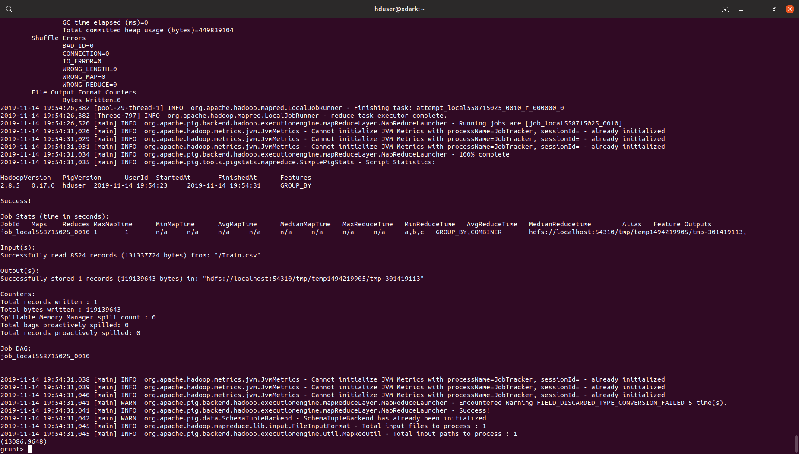

Output:- 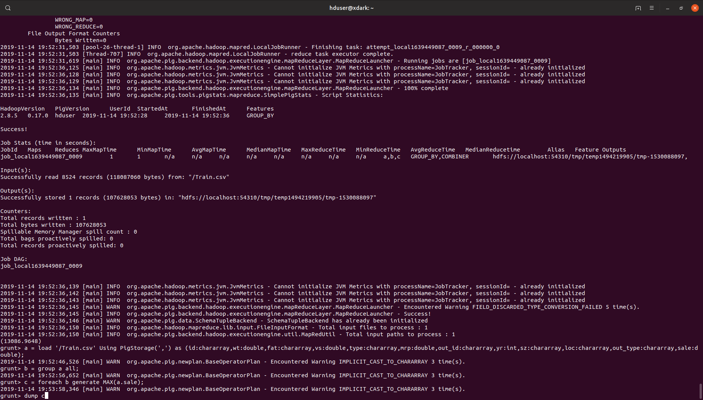

2.Check the availability of food in different outlet_type and outlet_Location_type

Query:- 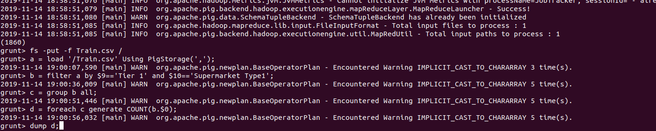

Output:- 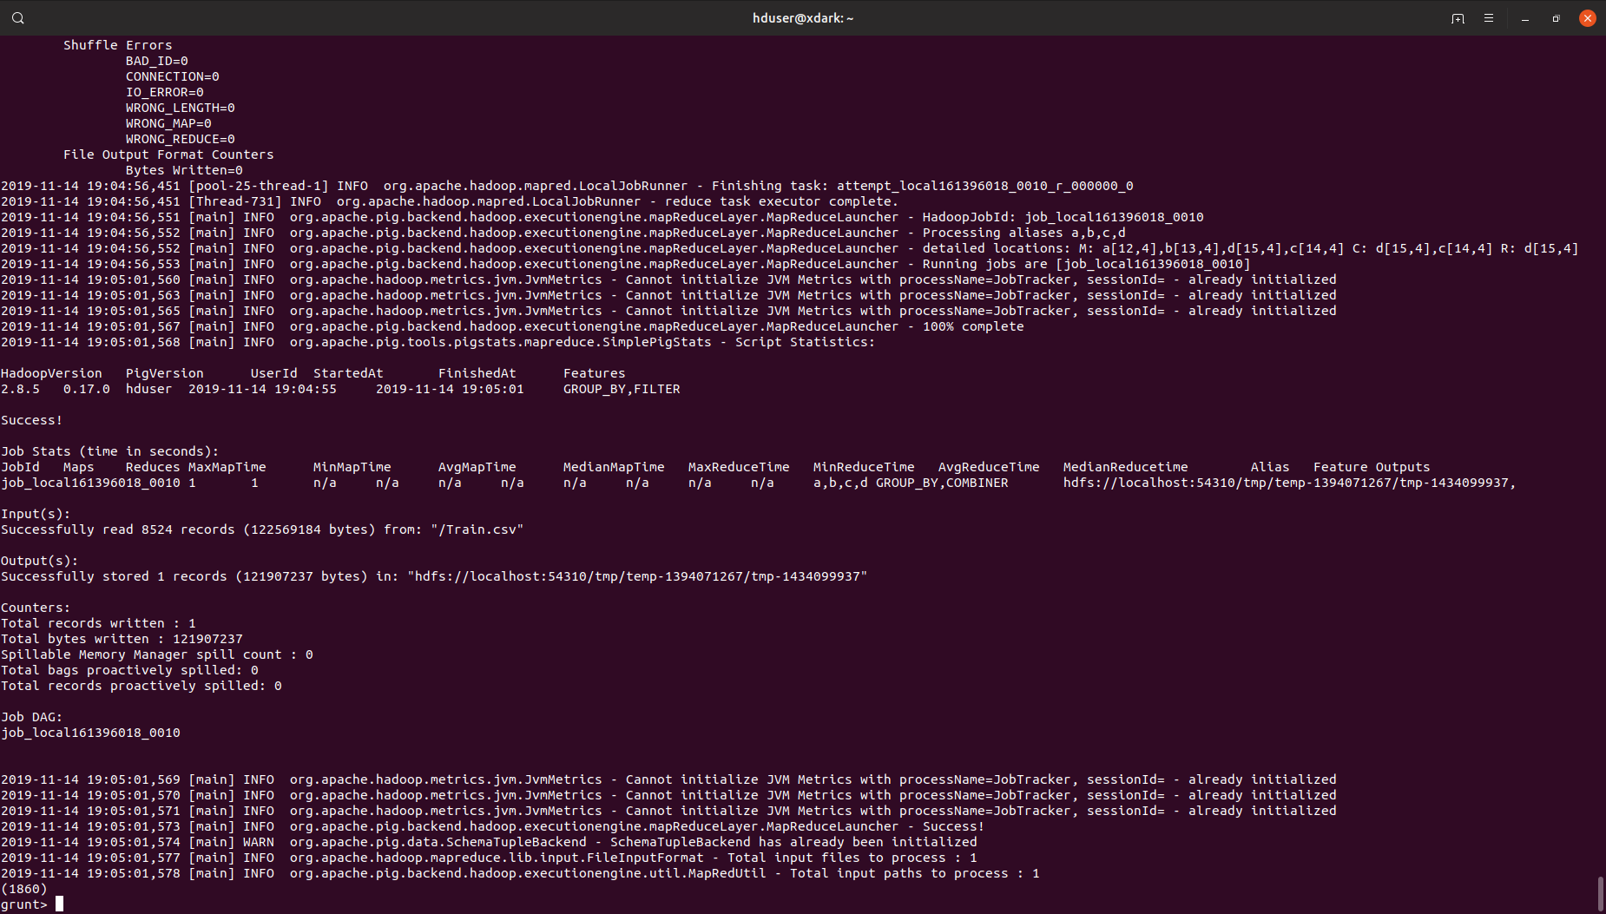

3. Total item_outlet_sales of a specific item-type in different outlet_type(store)

and outlet_size.

Query:- 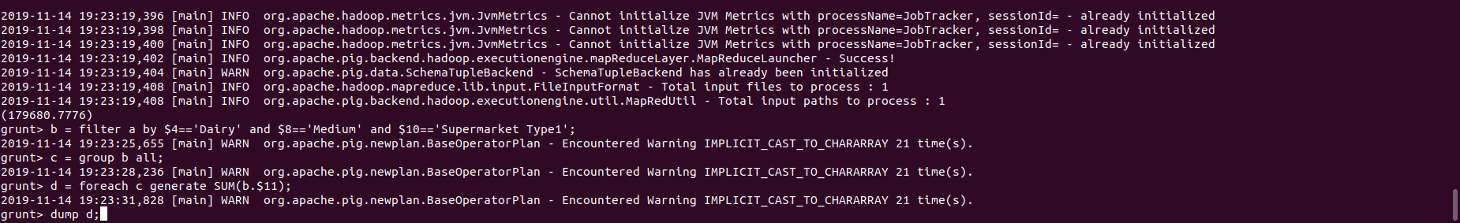

Output:- 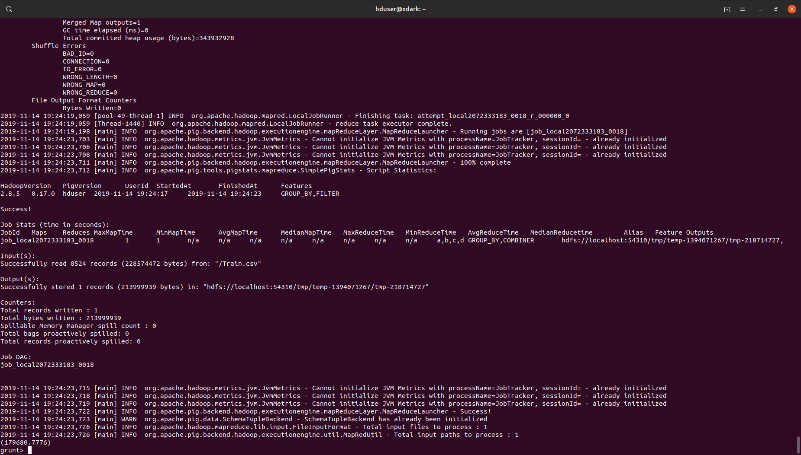

4. Display unique item type

Query:- 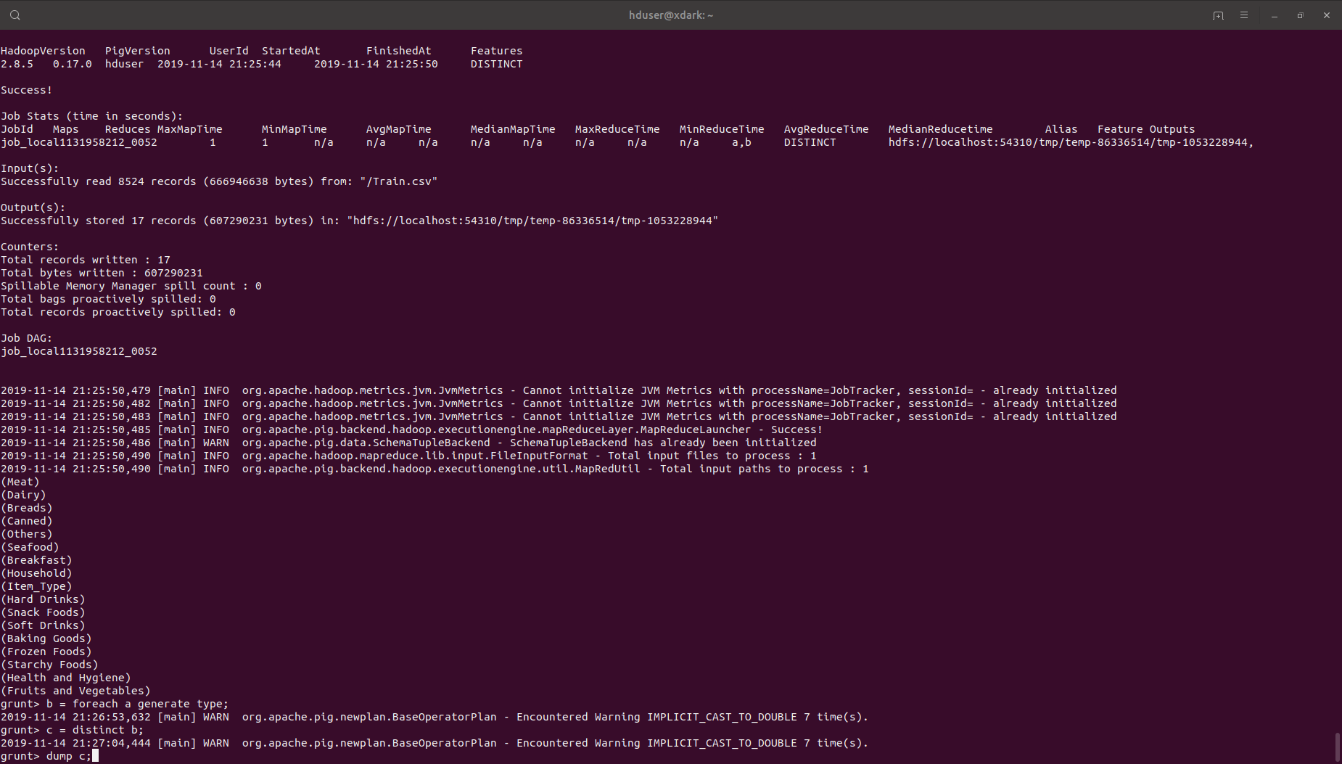

Output:- 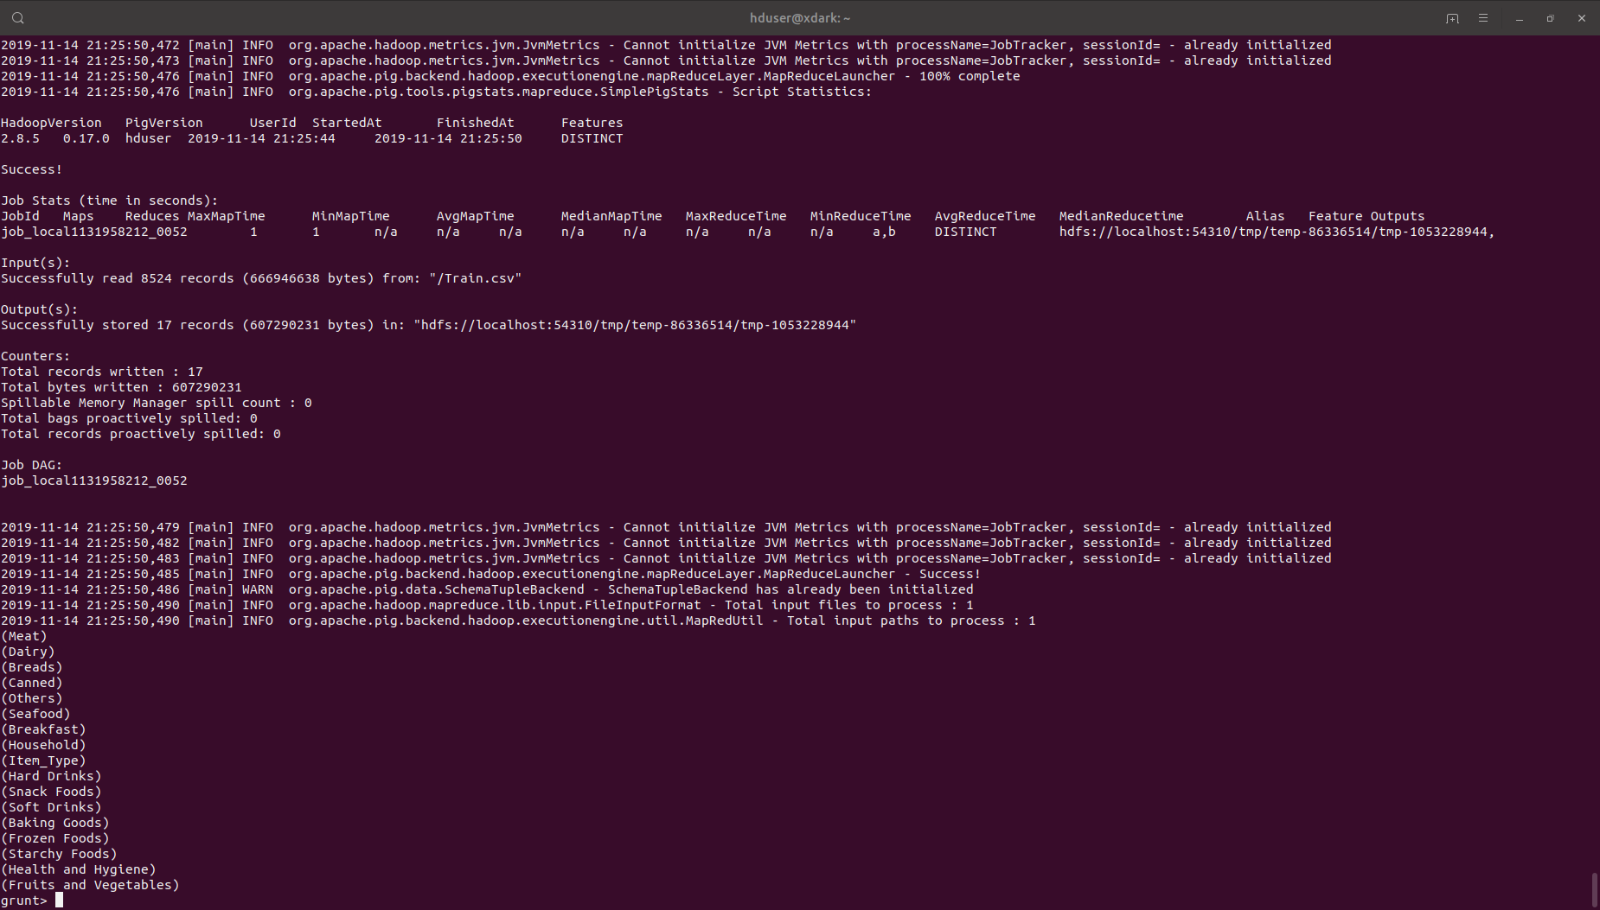

5. Get count of number of item-id which have low fat

Query:- 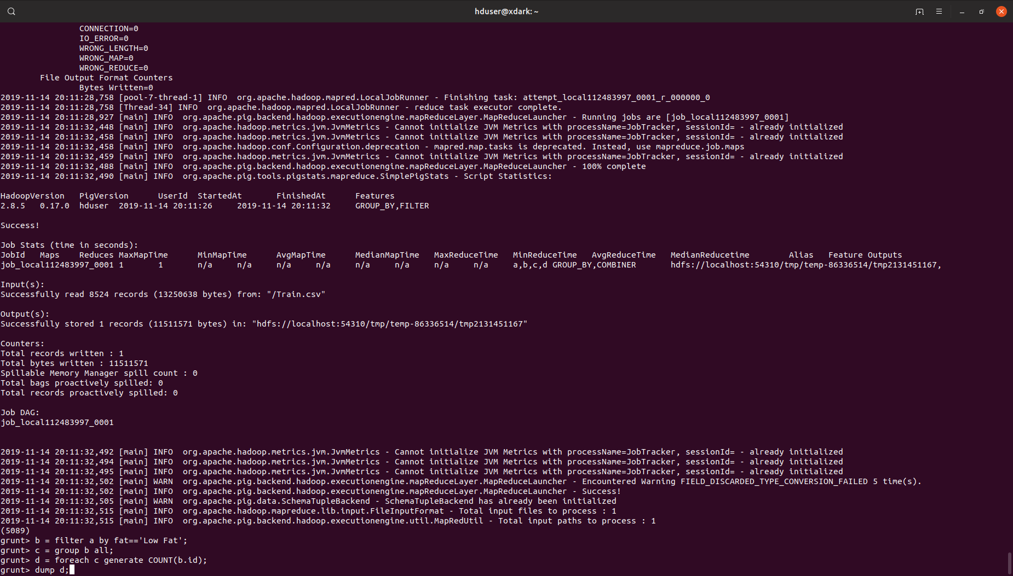

Output:- 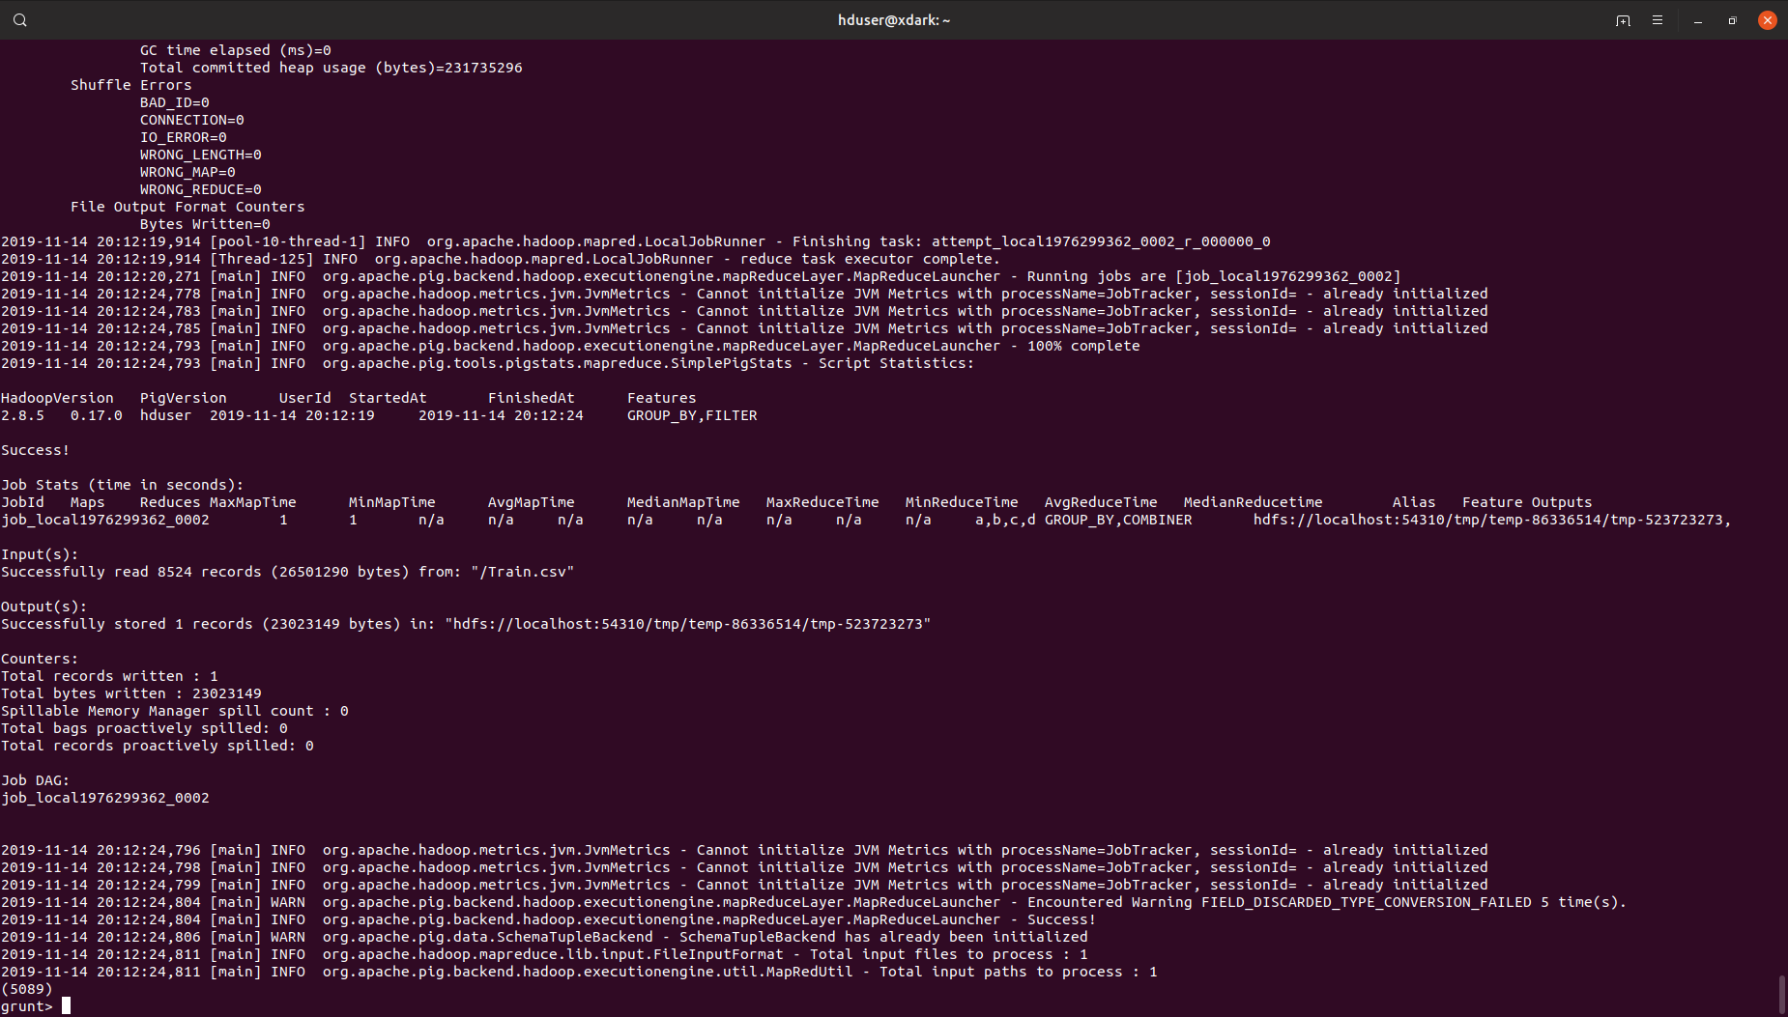

6. Display sum of outlet sale which belongs to tier 1

Query:- 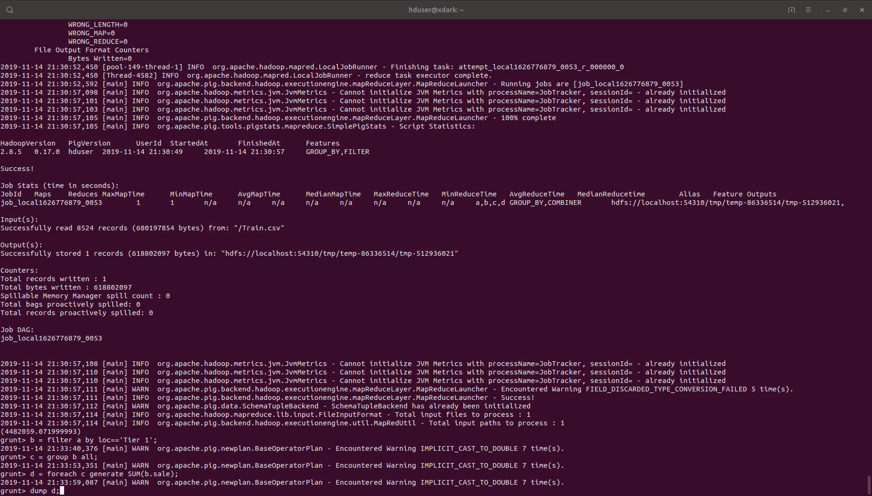

Output:- 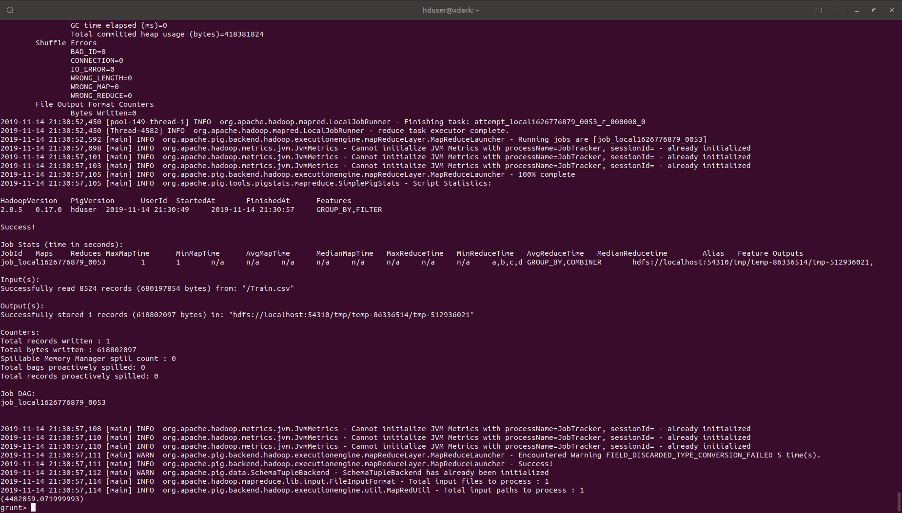

7. Get the count number of item_id which have weight in the range of". "

Query:- 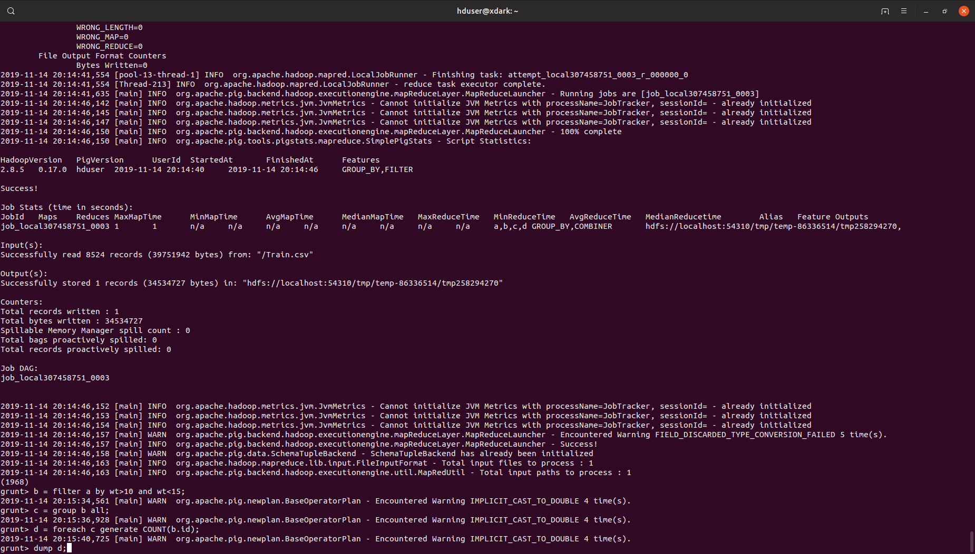

Output:- 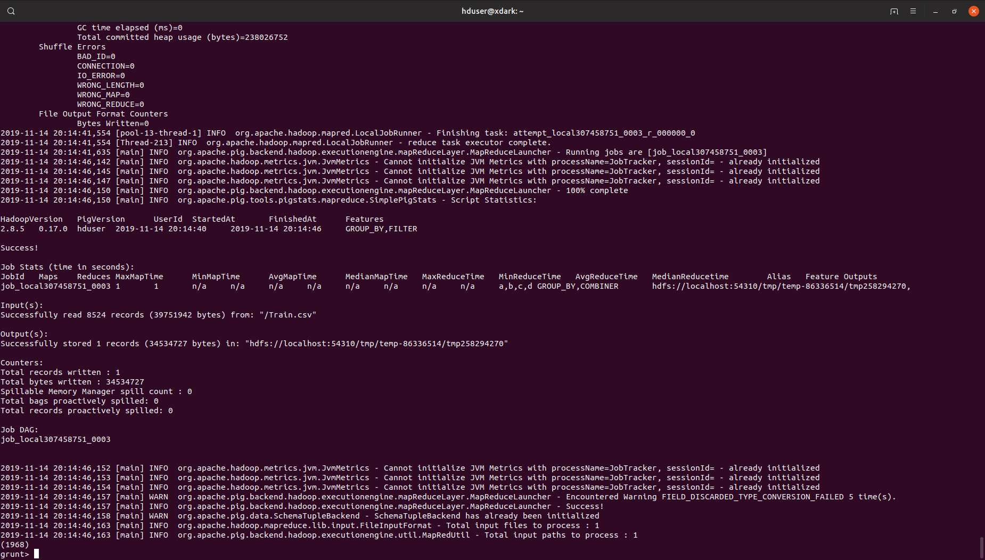

8. List the outlet size which is small display the year and type

Query:- 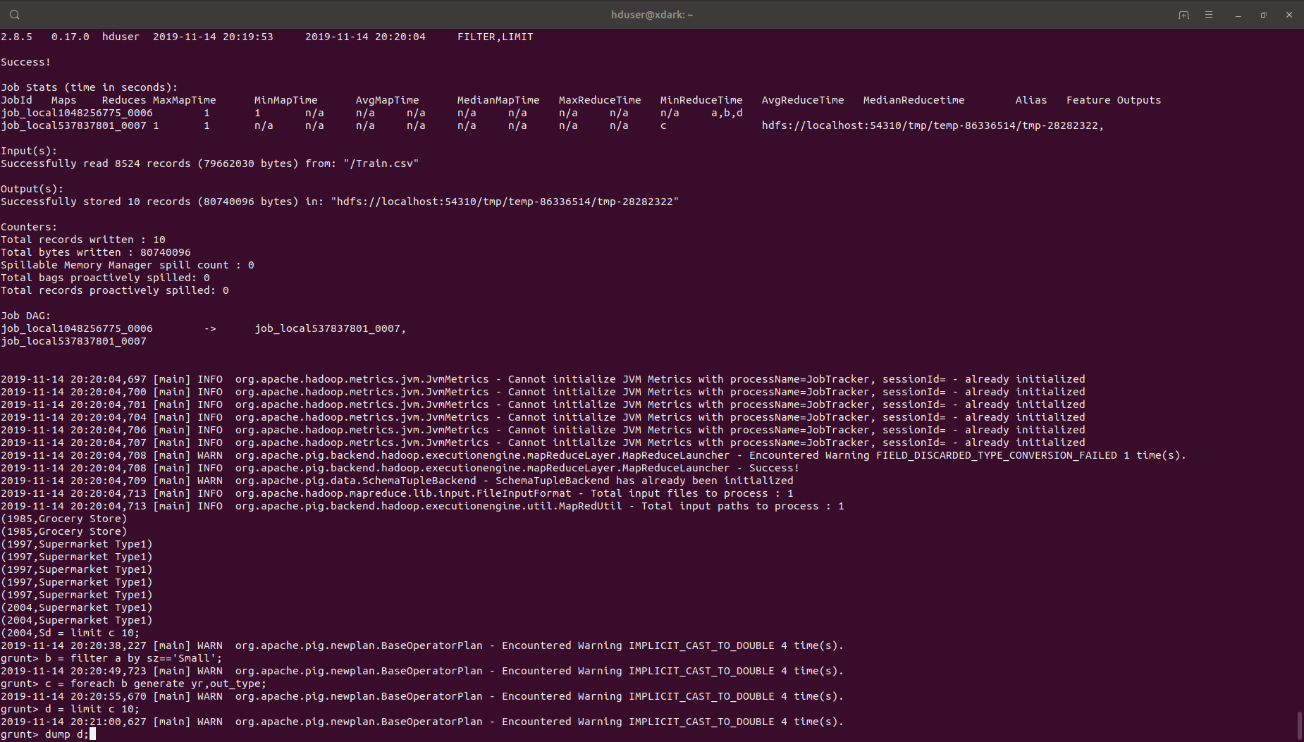

Output:- 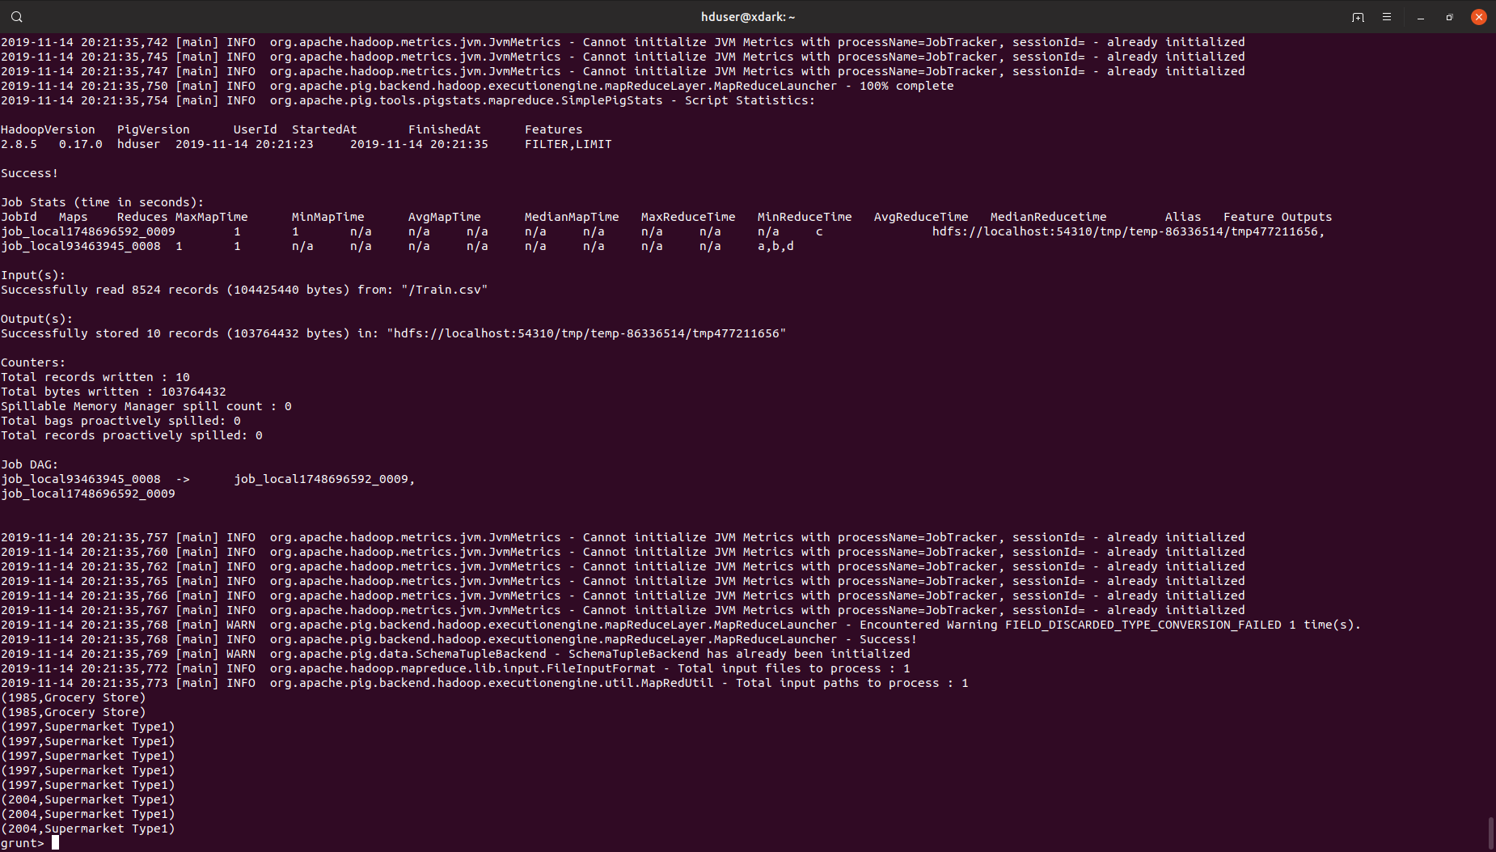

9.Display item type which have in range 100 to 200 mrp

Query:- 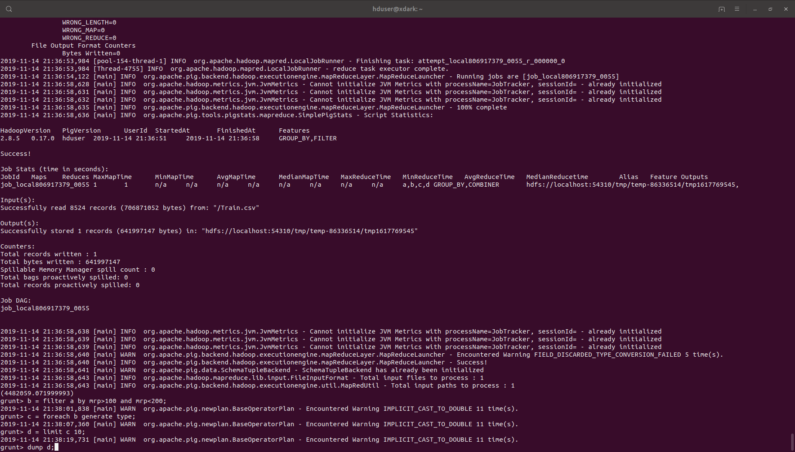

Output:- 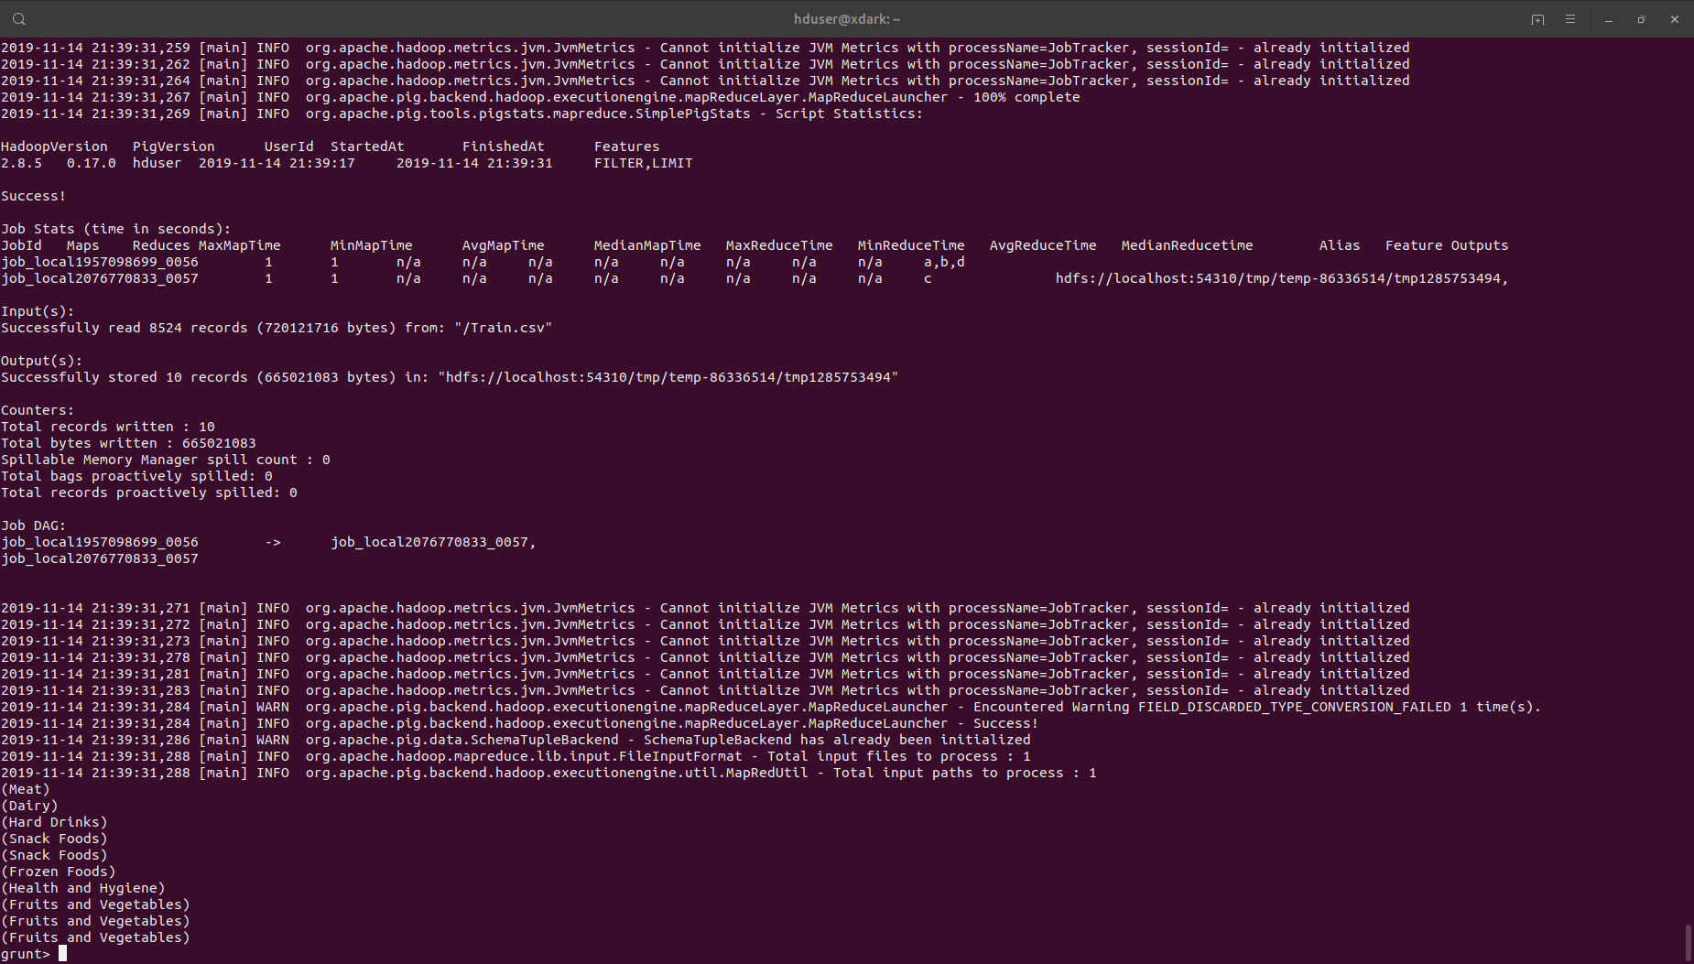

10. check the 0 visibility in different outlet_type(store) by outlet_id display itemid and itemtype

Query:- 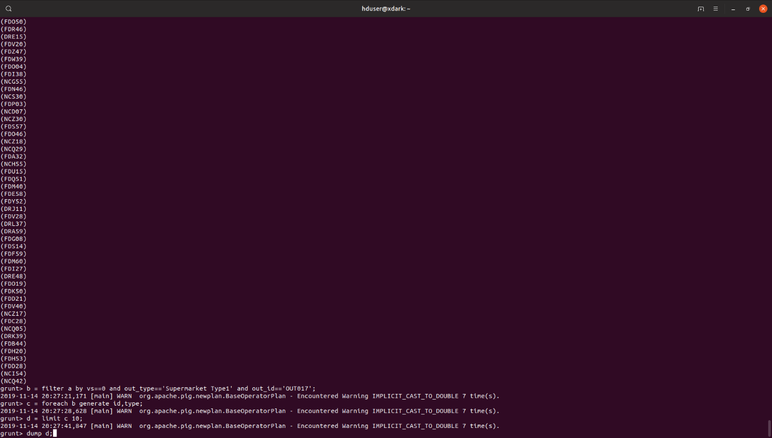

Output:- 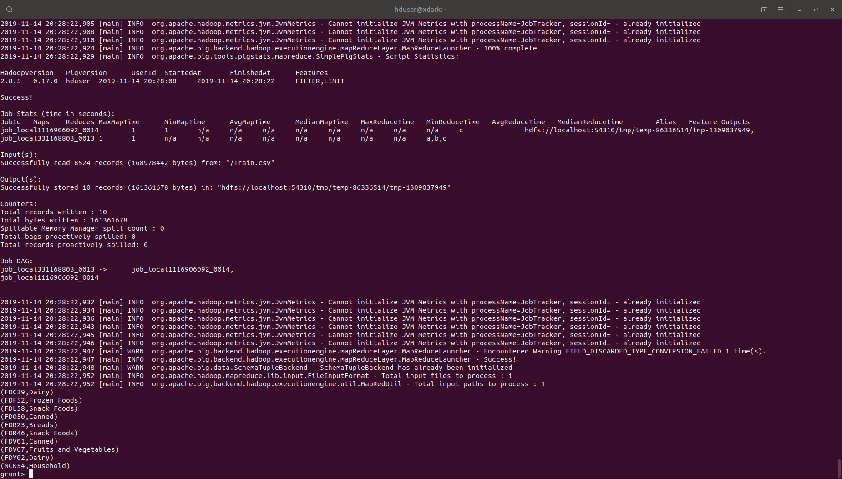

11. Display the item id and item type with item type which have null weight

Query:- 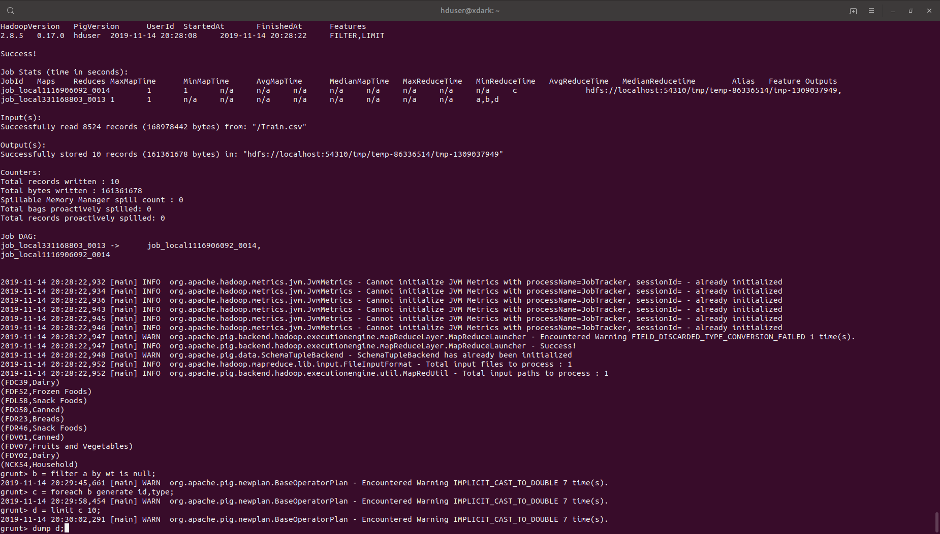

Output:- 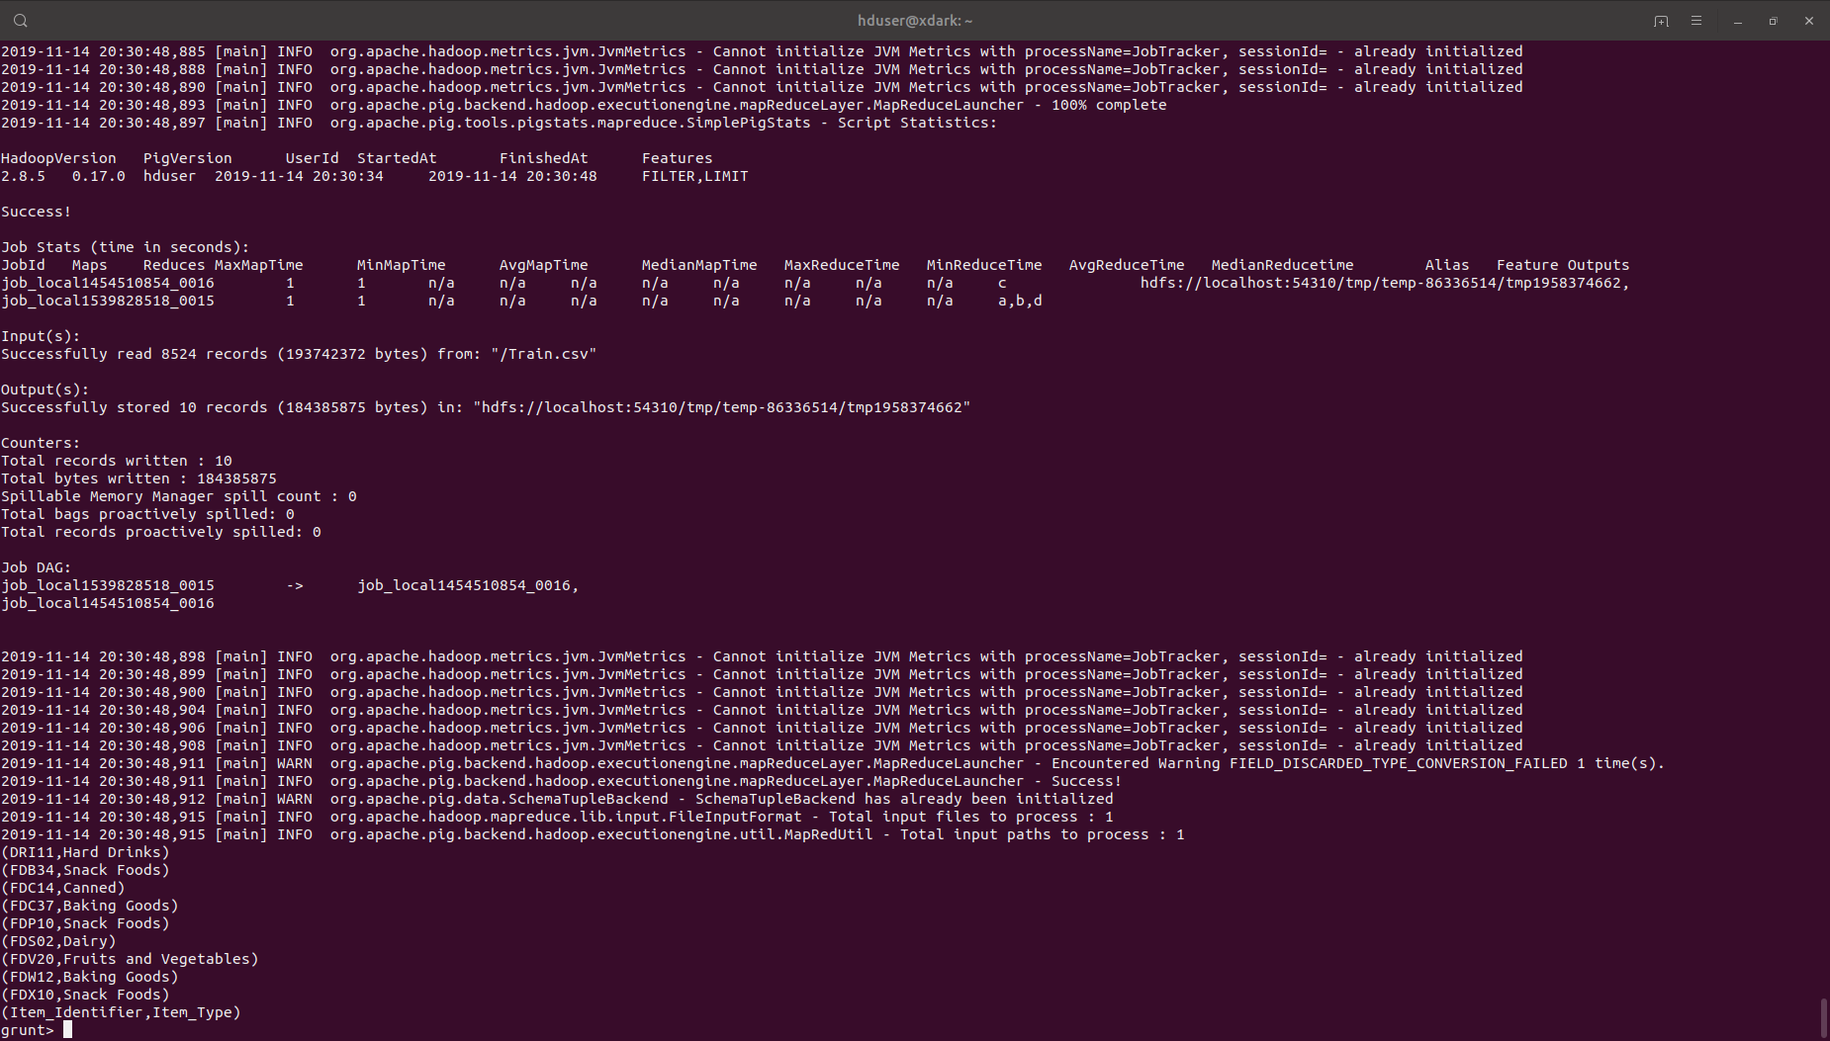

12. check the total visibility of a itemtype in different outlet_type(store) by outlet_id.

Query:-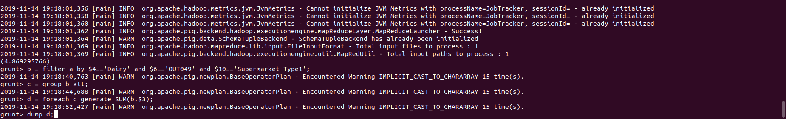

Output:-

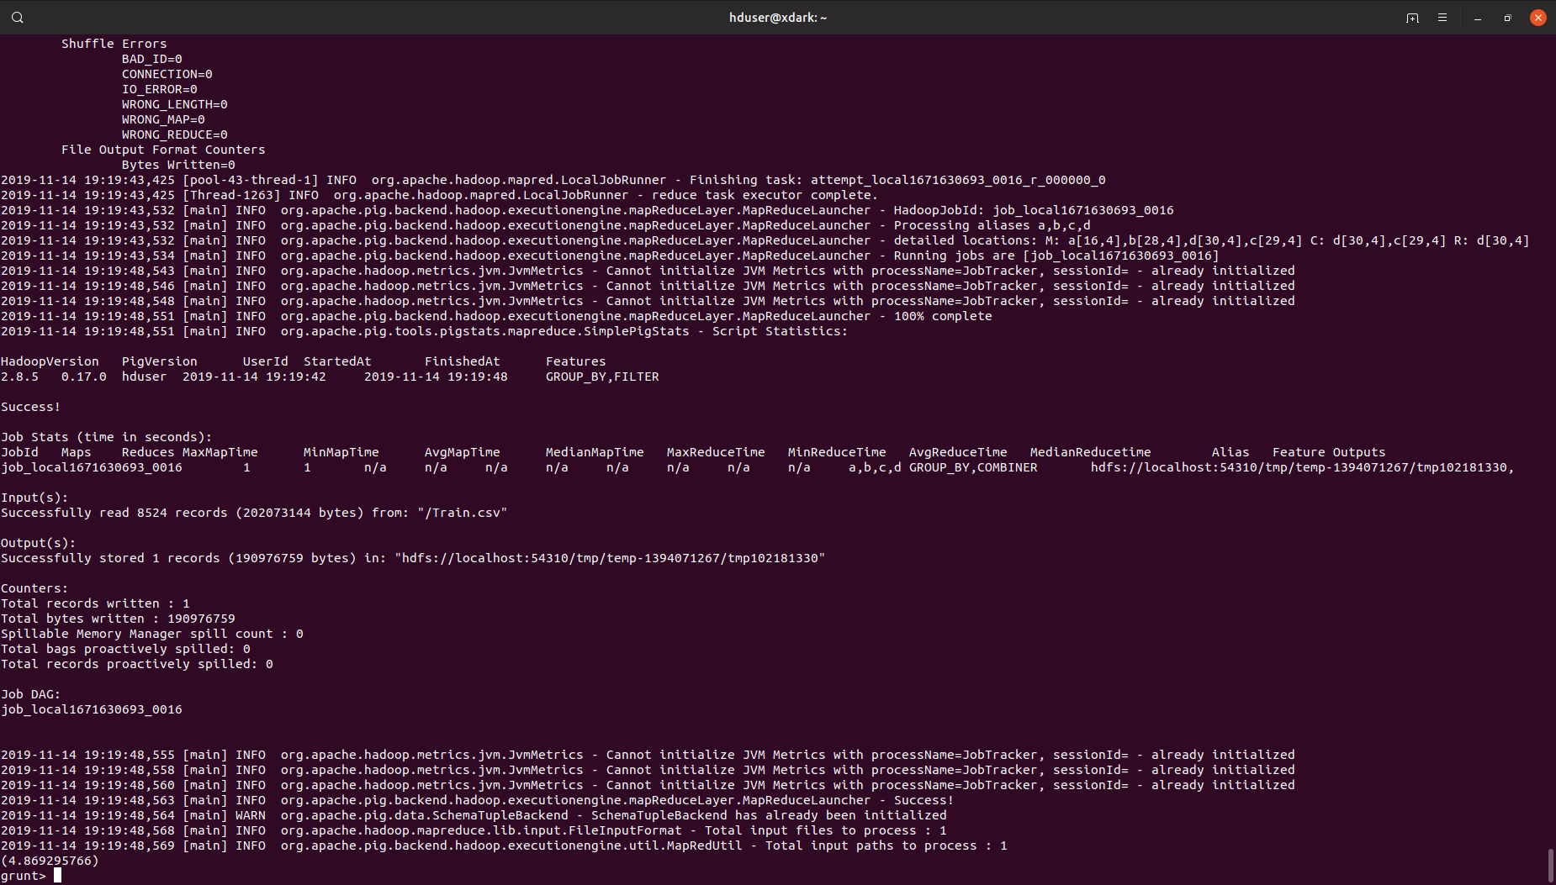

13. Display the year and outlet type in which grocery store or supermarket type 2 establish

Query:- 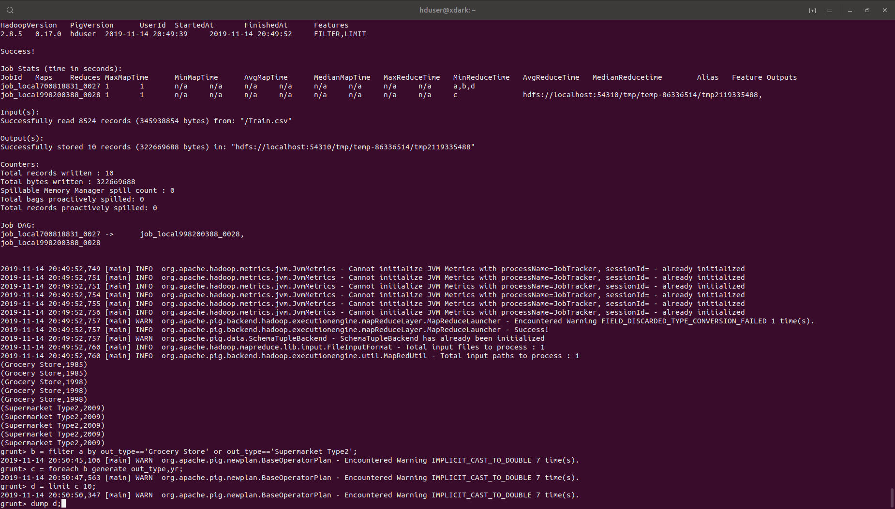

Output:- 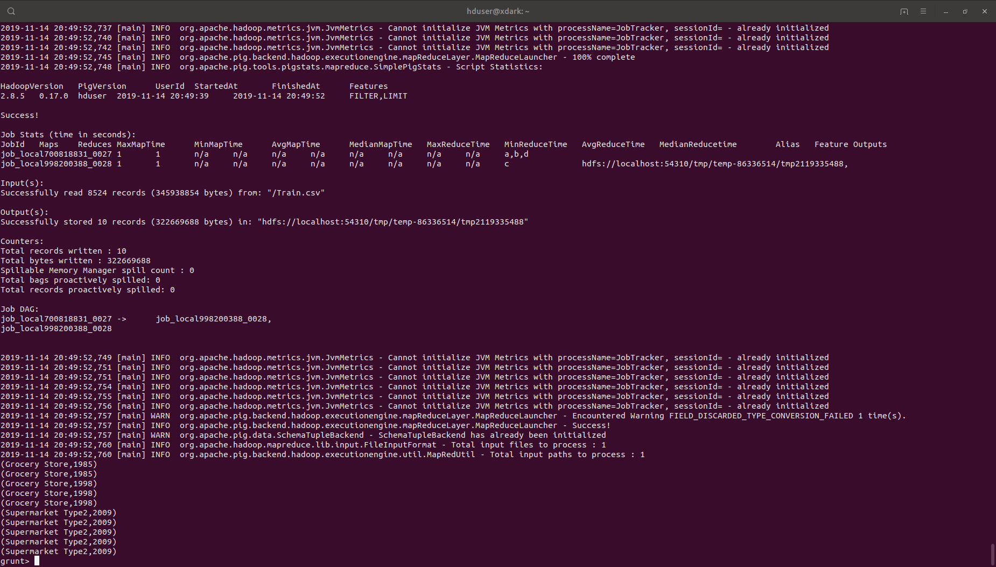

14.Display the outlet size and item type which have outlettype supermarket 1 and outlet size is not null.

Query:- 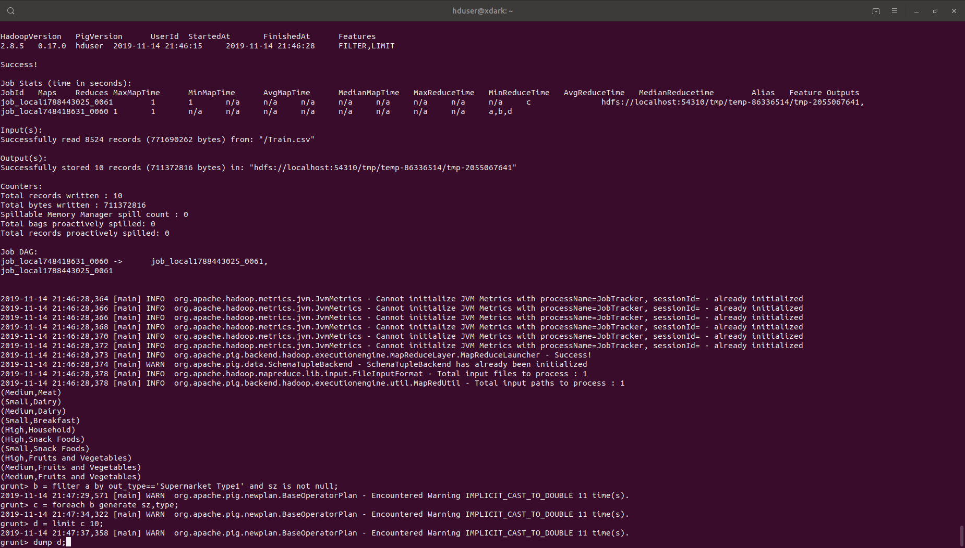

Output:- 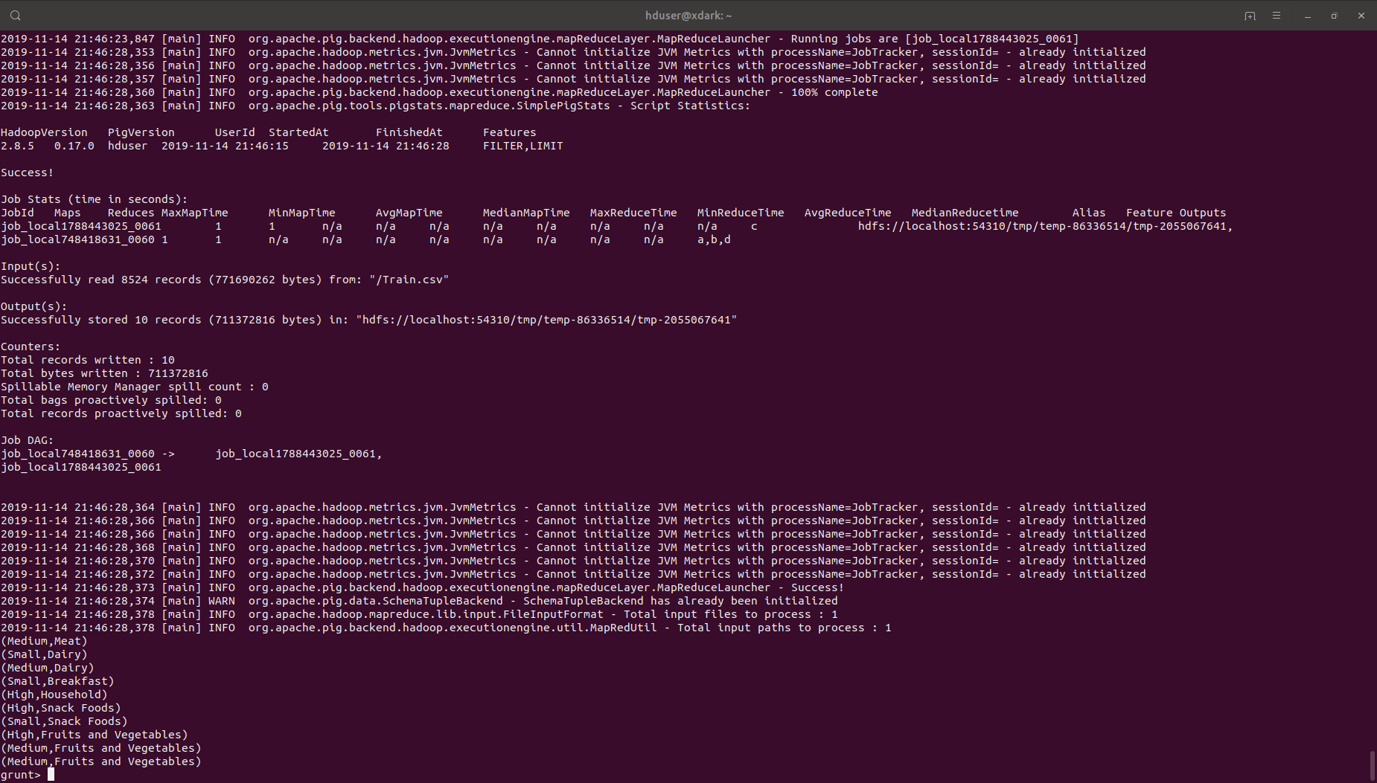

15. Display outlet sale and itemtype which belongs to supermarket type 3

Query:- 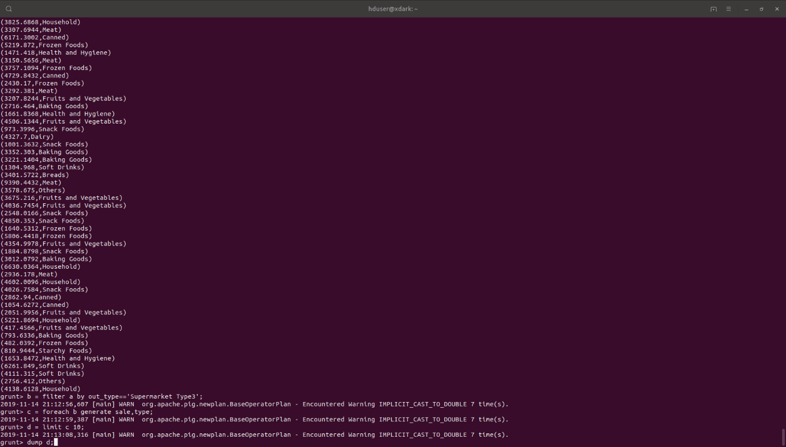

Output:- 